Regional Information Report No. 1J22-XX

Northern Southeast Inside Subdistrict Sablefish Management Plan and Stock Assessment for 2023

by

Philip Joy

and

Rhea Ehresmann

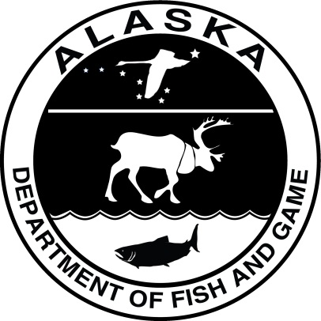

June 2022

Alaska Department of Fish and Game Divisions of Commercial Fisheries

Symbols and Abbreviations

The following symbols and abbreviations, and others approved for the Système International d'Unités (SI), are used without definition in the following reports by the Divisions of Sport Fish and of Commercial Fisheries: Fishery Manuscripts, Fishery Data Series Reports, Fishery Management Reports, and Special Publications. All others, including deviations from definitions listed below, are noted in the text at first mention, as well as in the titles or footnotes of tables, and in figure or figure captions.

**Weights and measures (metric)**

centimeter cm

deciliter dL

gram g

hectare ha

kilogram kg

kilometer km

liter L

meter m

milliliter mL

millimeter mm

**Weights and measures (English)**

cubic feet per second ft3/s

foot ft

gallon gal

inch in

mile mi

nautical mile nmi

ounce oz

pound lb

quart qt

yard yd

**Time and temperature**

day d

degrees Celsius °C

degrees Fahrenheit °F

degrees kelvin K

hour h

minute min

second s

**Physics and chemistry**

all atomic symbols

alternating current AC

ampere A

calorie cal

direct current DC

hertz Hz

horsepower hp

hydrogen ion activity pH

(negative log of)

parts per million ppm

parts per thousand ppt,

‰

volts V

watts W

**General**

Alaska Administrative

Code AAC

all commonly accepted

abbreviations e.g., Mr., Mrs., AM, PM, etc.

all commonly accepted

professional titles e.g., Dr., Ph.D.,

R.N., etc.

at @

compass directions:

east E

north N

south S

west W

copyright ©

corporate suffixes:

Company Co.

Corporation Corp.

Incorporated Inc.

Limited Ltd.

District of Columbia D.C.

et alii (and others) et al.

et cetera (and so forth) etc.

exempli gratia

(for example) e.g.

Federal Information

Code FIC

id est (that is) i.e.

latitude or longitude lat or long

monetary symbols

(U.S.) $, ¢

months (tables and

figures): first three

letters Jan,...,Dec

registered trademark ®

trademark ™

United States

(adjective) U.S.

United States of

America (noun) USA

U.S.C. United States Code

U.S. state use two-letter abbreviations (e.g., AK, WA)

**Mathematics, statistics**

*all standard mathematical*

*signs, symbols and*

*abbreviations*

alternate hypothesis HA

base of natural logarithm *e*

catch per unit effort CPUE

coefficient of variation CV

common test statistics (F, t, χ2, etc.)

confidence interval CI

correlation coefficient

(multiple) R

correlation coefficient

(simple) r

covariance cov

degree (angular) °

degrees of freedom df

expected value *E*

greater than >

greater than or equal to ≥

harvest per unit effort HPUE

less than <

less than or equal to ≤

logarithm (natural) ln

logarithm (base 10) log

logarithm (specify base) log2, etc.

minute (angular) ′

not significant NS

null hypothesis HO

percent %

probability P

probability of a type I error

(rejection of the null

hypothesis when true) α

probability of a type II error

(acceptance of the null

hypothesis when false) β

second (angular) ″

standard deviation SD

standard error SE

variance

population Var

sample var

Regional Information report XXX-XX

NORTHERN SOUTHEAST INSIDE SUBDISTRICT SABLEFISH management plan and Stock Assessment for 2023

by

Philip Joy

Alaska Department of Fish and Game, Division of Commercial Fisheries, Juneau

and

Rhea Ehresmann

Alaska Department of Fish and Game, Division of Commercial Fisheries, Sitka

Alaska Department of Fish and Game  
Division of Commercial Fisheries  
Regional Address

June 2022

The Regional Information Report Series was established in 1987 and was redefined in 2007 to meet the Division of Commercial Fisheries regional need for publishing and archiving information such as area management plans, budgetary information, staff comments and opinions to Alaska Board of Fisheries proposals, interim or preliminary data and grant agency reports, special meeting or minor workshop results and other regional information not generally reported elsewhere. Reports in this series may contain raw data and preliminary results. Reports in this series receive varying degrees of regional, biometric and editorial review; information in this series may be subsequently finalized and published in a different department reporting series or in the formal literature. Please contact the author or the Division of Commercial Fisheries if in doubt of the level of review or preliminary nature of the data reported. Regional Information Reports are available through the Alaska State Library and on the Internet at: <http://www.adfg.alaska.gov/sf/publications/>.

Product names used in this publication are included for completeness and do not constitute product endorsement. The Alaska Department of Fish and Game does not endorse or recommend any specific company or their products.

Philip Joy

Alaska Department of Fish and Game, Division of Commercial Fisheries,

1255 W. 8th Street, Juneau, AK 99801, USA

and

Rhea Ehresmann

Alaska Department of Fish and Game, Division of Commercial Fisheries,

304 Lake Street, Room 103, Sitka, AK 99835, USA

This document should be cited as follows:

Joy, P. and R. Ehresmann. 2022. Northern Southeast Inside Subdistrict sablefish management plan and stock assessment for 2022. Alaska Department of Fish and Game, Division of Commercial Fisheries, Regional Information Report 1J22-XX, Douglas.

The Alaska Department of Fish and Game (ADF&G) administers all programs and activities free from discrimination based on race, color, national origin, age, sex, religion, marital status, pregnancy, parenthood, or disability. The department administers all programs and activities in compliance with Title VI of the Civil Rights Act of 1964, Section 504 of the Rehabilitation Act of 1973, Title II of the Americans with Disabilities Act (ADA) of 1990, the Age Discrimination Act of 1975, and Title IX of the Education Amendments of 1972.

**If you believe you have been discriminated against in any program, activity, or facility please write:**

ADF&G ADA Coordinator, P.O. Box 115526, Juneau, AK 99811-5526

U.S. Fish and Wildlife Service, 4401 N. Fairfax Drive, MS 2042, Arlington, VA 22203

Office of Equal Opportunity, U.S. Department of the Interior, 1849 C Street NW MS 5230, Washington DC 20240

**The department’s ADA Coordinator can be reached via phone at the following numbers:**

(VOICE) 907-465-6077, (Statewide Telecommunication Device for the Deaf) 1-800-478-3648,

(Juneau TDD) 907-465-3646, or (FAX) 907-465-6078

**For information on alternative formats and questions on this publication, please contact:**

ADF&G, Division of Sport Fish, Research and Technical Services, 333 Raspberry Rd, Anchorage AK 99518 (907) 267-2375

TABLE OF CONTENTS

Page

LIST OF TABLES ii

LIST OF FIGURES ii

abstract 1

Introduction 1

2022 Sablefish management plan 2

Annual Harvest Objective Determination 2

Bycatch mortality in the halibut fishery 2

ADF&G longline survey removals 2

Sport fish harvest (guided and unguided) 2

Mortality from fishery deadloss 3

Personal use and subsistence harvest 3

Regulations 3

2022 Board of Fisheries Decisions 3

Registration and logbook requirements 3

Tagged sablefish 4

Sablefish possession and landing requirements 4

Fish ticket requirements 4

Bycatch allowances for other species 4

Sablefish live market 5

Prohibitions 5

2021 Sablefish Stock Assessment and 2022 RECOMMENDED ABC Determination 6

Changes to the 2021 NSEI Assessment Relative to 2020 6

Stock Assessment Results and Recommendations 7

ACKNOWLEDGEMENTS 10

REFERENCES CITED 10

Tables AND FIGURES 11

# LIST OF TABLES

Table Page

Table 1.–Annual harvest objective (round lb), equal quota share (round lb), reported harvest (round lb), exvessel value, number of permits, and effort (days) for the directed commercial Northern Southeast Inside (NSEI) Subdistrict sablefish fishery, 1985–2022. 12

Table 2.–Summary of key assessment results used to inform management in 2021 and 2022 and 2021. This table includes the estimates of projected total biomass (sablefish aged 2 years and above) and female spawning stock biomass, estimated biological reference points of unfished female spawning biomass *()*, female spawning biomass at 50% of unfished levels *()*, and the maximum target fishing mortality of . Additional values include the maximum permissible Acceptable Biological Catch (max ABC) defined by , the estimates of mortality from fishery releases that would result under max ABC and a discard mortality rate of 0.16, and the recommended ABC under the max 15% change management procedure. 13

Table 3.–Decrement types and amounts, 2017–2022. Estimated catch is in round pounds of sablefish. 14

Table 4.–Sablefish harvest (round pounds) from the Northern Southeast Inside Subdistrict (NSEI) longline survey, 1988–2022, survey removal decrement (survey harvest minus the combined harvest allocated to the equal quota shares of permit holders aboard the survey vessels), and the number of permit holders participating in the survey. 15

# LIST OF FIGURES

Figure Page

Figure 1.–Northern Southeast Inside (NSEI) and Southern Southeast Inside (SSEI) Subdistricts including restricted waters of Glacier Bay National Park and Preserve and Annette Islands Reserve. 16

Figure 2.–Catch, landings by port, and ex-vessel value for Northern Southeast Inside (NSEI) Subdistrict commercial sablefish 1985–2021. The asterisk denotes the COVID-19 pandemic and potential effects on ex-vessel value in 2021. 17

Figure 3.–Fits to indices of catch and abundance with the assumed error distribution shown as shaded grey polygons. Input data are shown as grey points and model fits are shown in black. Indices include (A) harvest (million round pounds); (B) fishery catch per unit effort in round pounds with separate selectivity and catchability time periods before and after the implementation of the Equal Quota Share (EQS) program in 1994; (C) survey catch per unit effort in number of fish per hook; and (D) mark-recapture abundance estimates in millions. Solid and dashed-lines in panel D reflect years for which data were and were not available, respectively. 18

Figure 4.–Model predictions of (A) age-2 recruitment (millions); (B) female spawning stock biomass (million pounds); (C) exploitable abundance (millions); and (D) exploitable biomass (million pounds). 19

Figure 5.–Mohn’s  and retrospective peels of sablefish spawning biomass. 20

Figure 6.–Fits to fishery age compositions, 2002–2021. Observed (gray bars) and predicted proportions-at-age (black lines) shown. 21

Figure 7.–Fits to survey age compositions, 1997–2021. Observed (gray bars) and predicted proportions-at-age (black lines) shown. 22

Figure 8.–Fits to female fishery length compositions, 2002–2021. Observed (gray bars) and predicted proportions-at-age (black lines) shown. 23

Figure 9.–Fits to male fishery length compositions, 2002–2021. Observed (gray bars) and predicted proportions-at-age (black lines) shown. 24

Figure 10.–Fits to female survey length compositions, 1997–2021. Observed (gray bars) and predicted proportions-at-age (black lines) shown. 25

Figure 11.–Fits to male survey length compositions, 1997–2021. Observed (gray bars) and predicted proportions-at-age (black lines) shown. 26

# abstract

This report provides an overview of the stock assessment, harvest strategy, and regulations effective for the 2023 Northern Southeast Inside (NSEI) sablefish (*Anoplopoma fimbria)* commercial fishery. The NSEI sablefish commercial fishery is scheduled to open August 15 and close November 15 and open to both longline and pot gear. The 2023 NSEI sablefish commercial fishery annual harvest objective is 1,233,633 round pounds and is based on decrements from an acceptable biological catch of 1,573,109 round pounds. The annual harvest objective is allocated to 73 limited entry Commercial Fisheries Entry Commission C61A permits through an equal quota share (EQS) system, resulting in a 2023 EQS of 16,899 round pounds for each permit holder.

Key words: sablefish, black cod, *Anoplopoma fimbria*, stock assessment, annual harvest objective, AHO, catch per unit effort, CPUE, Northern Southeast, Chatham Strait, NSEI, mark–recapture, tagging

# Introduction

The Alaska Department of Fish and Game (ADF&G) evaluates stock status and establishes the Northern Southeast Inside (NSEI) acceptable biological catch (ABC) and subsequent annual harvest objective (AHO). The NSEI Subdistrict management area (Figure 1) consists of all waters as defined in 5 AAC 28.105(a)(2).

The 2023 NSEI Subdistrict commercial sablefish fishery AHO is 1,233,633 round pounds (Table 1). There are 73 valid Commercial Fisheries Entry Commission (CFEC) permits for 2023, which is the same number as 2021. The individual equal quota share (EQS) is 16,899 round pounds, an 8.4% increase from the 2022 EQS of 16,899 round pounds (Table 1). The AHO is based on the sablefish ABC (Table 2) with decrements made for sablefish mortality in other fisheries (Table 3).

The recommended 2023 ABC is 1,573,109 round pounds ( = 0.063), a 9% increase from the 2022 ABC (Table 2). There are 75 valid Commercial Fisheries Entry Commission permits for 2023, which is a reduction of 3 permits from 78 permit holders in 2022. The individual equal quota share (EQS) is 14,773 round lb, a 25% increase from the 2022 EQS of 11,796 round lb (Table 1). The AHO is based on the sablefish ABC (Table 2) with decrements made for sablefish mortality in other fisheries (Table 3; Figure 2).

Several advancements to the stock assessment and statistical catch-at-age (SCAA) model were implemented for the 2023 NSEI sablefish assessment that improved the model’s ability to capture the dynamics of the stock. These advancements are:

1. Fishery CPUE was fully standardized to correct for variability in fishing methods and practices (i.e, hook size, fishing depth, length of sets, location, etc.) to better detect underlying trends that reflect the abundance of fish available to the fishery. This involved recalculating fishery CPUE from the re-entered logbook data that was completed in 2020.
2. Fishery selectivity in the SCAA was updated to the fixed values estimated in the federal sablefish fishery assessment (Goethel et al. 20XX). Selectivity in the time period prior to implementation of the IFQ fishery in 1995 changed significantly from the last assessment such that the curve is substantially less steep such that fewer, smaller fish were being selected for than previously estimated. This has the effect of increasing the apparent size of the population during that time period and thus reducing stock status today. The model is now capable of estimating fishery selectivity within the model, but the estimated selectivity curves are suspect and further work needs to be done before this version of the model is implemented.
3. Survey selectivity was switched from the fixed values borrowed from the federal domestic longline survey values to being freely estimated in the SCAA model, thus being a more accurate reflection of the NSEI longline survey. This involved adding a second time block to reflect the switch from an unstandardized survey prior to 2000 and the fully standardized fishery that began in 2000.
4. The recruitment process is now modelled using random effects which allows for the estimation of variability, *sR*. Prior to this assessment, *sR* had been fixed at the assumed federal assessment value of 1.2.
5. The data weighting of the model was changed to reflect best practices in SCAA modelling. This involved tuning the age and length compositional data to adjust the effective sample sizes using McAllister and Ianelli (1997) and removing the fixed weights that had been applied to the abundance indices (mark-recapture estimates, longline survey CPUE and longline fishery CPUE). The variance of the longline survey was changed from assumed values to the true estimates. The fishery CPUE and mark-recapture variance was kept at the inflated and fixed values to allow for the extra uncertainty in these indices owing to the unrecorded releases of fish that are permitted in the fishery and unquantified biases in the mark-recapture project.

With these changes, the recommended 2023 ABC is 1,573,109 round lb (*FABC* = 0.063), a 9% increase from the 2022 ABC. The increase in the ABC is attributed to the continued growth and maturation of the strong recruitment events since 2015, highlighted by recruitment in 2018 (the 2016 year class) which is the highest recruitment since 1979. The dominant 2016 year class is now 50% mature and will comprise 27% of the biomass. All three abundance estimates are elevated from recent years with the highest abundance estimate on record from the mark-recapture project, the third sustained year of high CPUE in the longline survey and increasing CPUE in the longline fishery. However, the lower stock status estimated in the new model results in less of an increase than was present in using the 2022 model (the base model). The recommended ABC is thus an average of the recommended ABC from the base model used in past assessments and the new model v23 used in this assessment. Fishery catch and ex-vessel value remain depressed from historical levels, but have increased since 2022 as the 2013-2019 year classes reach marketable sizes and are being landed and retained in the fishery (Figure 2). Though recent high catch rates of small sablefish across multiple geographic areas signal increasing trends for sablefish stocks (Goethel et al. 2021), the department maintains a precautionary approach to setting harvest limits. Estimates from the 2022 stock assessment suggest sablefish spawning stock biomass remains at suppressed levels compared to the 1980s and 1990s.

The ABC determination process uses a statistical catch-at-age model, which was first implemented in 2020. The model reduces the reliance on the annual mark-recapture project to estimate recruitment, abundance, and spawning stock biomass of NSEI sablefish by integrating multiple indices of abundance and biological data (e.g., catch, mark-recapture abundance estimates, longline survey and fishery CPUE, longline survey length and age compositions). As in previous years, maximum ABC is defined by , the fishing mortality rate that reduces spawning biomass to 50% of equilibrium unfished levels.

The process leading to the determination of the ABC, AHO, and EQS includes compiling fishery and survey data, running the stock assessment, and accounting for additional sources of mortality through decrements. Although the ABC is determined prior to the AHO and EQS, this report is organized to make management-related information accessible to stakeholders and improve documentation of the assessment process by organizing this report into the following sections:

1. 2023 Sablefish Management Plan: details the decrements process leading to the AHO and EQS and effective regulations for the 2023 NSEI fishery.
2. 2022 Sablefish Stock Assessment and 2023 ABC Determination: highlights stock assessment data inputs, methods, results, and subsequent analyses that informed the recommended ABC.

# 2023 Sablefish management plan

## Annual Harvest Objective Determination

The 2023 AHO was determined by making the following decrements from the recommended ABC (1,573,109 round pounds, Tables 2 and 3):

* estimated sablefish bycatch mortality in the commercial Pacific halibut fishery,
* ADF&G longline survey removals,
* sport fishery guided and unguided harvest,
* mortality from fishery deadloss, and
* subsistence and personal use harvest.

### Bycatch mortality in the halibut fishery

Sablefish caught in NSEI during the Pacific halibut individual fishing quota fishery prior to the sablefish fishery season opening (August 15) must be released; however, because not all are expected to survive, bycatch mortality is estimated. Prior to 2003, a 50% bycatch morality rate was applied as bycatch sablefish were permitted to be retained as bait. In 2003, the Alaska Board of Fisheries disallowed retaining bycatch sablefish for bait, and a 25% bycatch mortality rate was assumed for all sablefish caught and released due to the larger hook size in the Pacific halibut fishery. Released sablefish bycatch is calculated as the product of the 3-year average of the sablefish to Pacific halibut ratio from the International Pacific Halibut Commission (IPHC) annual survey and the 3-year average of the Pacific halibut catch in areas greater than 99 fathoms in NSEI.

### ADF&G longline survey removals

In 2022, no NSEI permit holders will participate in the NSEI longline survey due to budgetary instability and deficit given the low prices of sablefish in 2020 and 2021 (Tables 3 and 4). The survey removal decrement was determined by averaging the survey total harvest from the previous 3 years. Permit holders will likely resume survey participation in 2023.

### Sport fish harvest (guided and unguided)

Sablefish sport fish preliminary harvest and release mortality from the guided and unguided sectors are estimated utilizing charter logbooks and the statewide harvest survey (Romberg et al. 2017). Estimates of harvested and released fish are based on the total number of fish and converted to weight using a 3-year average of fish sampled from the guided and unguided sectors. A 10% release mortality rate is applied to the sport fishery; this was based on the 11.7% estimated in Stachura et al. (2012) and modified to account for difference in gear type (rod and reel versus longline) and handling time.

### Mortality from fishery deadloss

Deadloss mortality in the directed sablefish fishery was estimated by applying the percentage of dead sablefish (i.e., recorded as predated by sand fleas, sharks, hooking injury, or other cause of mortality) caught on the NSEI longline survey using the recent 3-year average, 0.85% (2019–2021), to the NSEI sablefish commercial AHO.

### Personal use and subsistence harvest

A total of 772 personal use and subsistence sablefish permits were issued in 2021. Annual subsistence and personal use harvest of sablefish is estimated from these permits by adding the total number of retained sablefish reported to the proportion of released sablefish reported after applying a 16% discard mortality rate to released sablefish (Gilroy and Stewart 2013). The Pacific halibut fishery is assumed a reasonable proxy for sablefish because the fisheries utilize similar gear and frequently the same vessels and crew participate in both fisheries. Moreover, both species are considered hardy and do not experience barotrauma. The 2021 longline survey average weight (5.1 lb) was applied to this harvest to obtain a decrement total.

In 2015, personal use harvest was limited to an annual limit of 50 fish per household. Since 2018, participants of the personal use fishery have been allowed to use pot gear with no more than 2 pots per permit and a maximum of 8 pots per vessel when 4 or more permit holders are on board the same vessel. Use of pot gear has continued to increase with 68% of permit holders fishing pots.

## Regulations

### 2022 Board of Fisheries Decisions

In March 2022, the Alaska Board of Fisheries adopted new regulations that will be enacted prior to or during the fishing season for the NSEI sablefish commercial fishery. An advisory announcement will be issued at a later date with more information. These new regulations include:

* Full retention requirements and landing requirements using hook-and-line and pot gear for all species of rockfish including thornyhead rockfish.
* Allowing pot gear as a legal gear type in addition to longline gear for the C61A permits, which is contingent upon the approval process through CFEC.
* If pot gear is approved as a legal gear type for the C61A permits, pots must have at least two circular escape rings, with a minimum inside diameter of three and three-fourths inches, installed on opposing vertical or sloping walls of the pot.

### Registration and logbook requirements

Fishermen must register prior to fishing [5 AAC 28.106 (b)] and keep a logbook during the fishery. Completed logbook pages must be attached to the ADF&G copy of the fish ticket at the time of delivery. Confidential envelopes for logbook pages may be requested when registering.

Permit holders will receive a personal quota share (PQS) tracking form at the time of registration. This form is used to record the total round weight landed for each delivery. Each permit holder must, upon request, provide the buyer with the total round weight of sablefish the permit holder has landed to date. The department requests that a copy of the completed PQS tracking form is included with the final fish ticket of the season for that permit.

Logbooks must include, by set, the date and time gear is set and retrieved, specific location of harvest by latitude and longitude for start and ending positions, hook spacing, amount of gear (number of hooks and skates) used, depth of set, estimated number or weight of the target species, and the estimated number or weight of bycatch by species. Permit holders must indicate for each set if the target species was sablefish or Pacific halibut and if there was any gear lost. A permit holder must retain all visibly injured or dead sablefish. Sablefish that are not visibly injured or dead may be released unharmed, and the permit holder must record in the logbook, by set, the number of live sablefish released [5 AAC 28.170(f)]. Permit holders must record release reason (e.g., fish are small) and whether their personal quota share has been met.

### Tagged sablefish

Fishermen are requested to watch for tagged sablefish, record tag number(s), and attach tags directly in the logbook with the corresponding set information. All tags returned will receive a reward. Tag rewards include a t-shirt and entry into an annual drawing for one $1,000, two $500, and four $250 cash rewards. To qualify for entry in the annual drawing, ADF&G requires the following information: the tag, set location (latitude and longitude), date of capture of the fish, and the name and address of the person recovering the tag.

### Sablefish possession and landing requirements

In the NSEI Subdistrict, the holder of a CFEC permit for sablefish may not retain more sablefish from the directed fishery than the annual amount of sablefish EQS specified by the department [5 AAC 28.170 (f)]. However, if a permit holder’s harvest exceeds the EQS for that year, by not more than 5%, ADF&G shall reduce the permit holder's EQS for the following year by the amount of the overage. If a permit holder's harvest exceeds the permit holder's EQS by more than 5%, the proceeds from the sale of the overage in excess of 5% shall be surrendered to the state and the permit holder may be prosecuted under AS 16.05.723 [5 AAC 28.170 (j)]. If a permit holder’s harvest is less than the permit holder’s EQS established for the year, ADF&G shall increase the permit holder’s PQS only for the following year by the amount of the underage that does not exceed 5% of the EQS [5 AAC 28.170 (k)]. For the 2022 fishing season, 5% of the annual EQS is 845 round pounds.

### Fish ticket requirements

Landed weights must be recorded on a fish ticket at the time of delivery. If a fisherman delivers fish in the round, the total round weight delivered must be recorded on the fish ticket. If a fisherman delivers dressed fish, the fish ticket must include the total landed dressed weight as well as the round weight equivalent, determined by using the standard 0.63 recovery rate. There is a 2% allowance for ice and slime when unrinsed whole iced sablefish are weighed. A fish ticket must be completed prior to the resumption of fishing and each permit holder must retain, on board their vessel, copies of all NSEI sablefish tickets from the current season and their updated PQS tracking form. When delivering fish out of state, a completed fish ticket must be submitted to ADF&G prior to transporting fish out of Alaska.

### Bycatch allowances for other species

Full retention and reporting of rockfish *Sebastes*, excluding thornyhead rockfish *Sebastolobus*, is required for internal waters (5 AAC 28.171). The full retention regulation does not apply to thornyhead rockfish at the time of publication but will when the new regulations become effective in 2022. The allowable bycatch that may be legally landed and sold on an NSEI sablefish permit is based on round weight of sablefish and bycatch species or species group on board the vessel:

* All rockfish, including thornyheads: 15% in aggregate, of which 1% may be demersal shelf rockfish (DSR), which includes yelloweye, quillback, canary, tiger, copper, China, and rosethorn rockfish
* Lingcod: 0%
* Pacific cod: 20%
* Spiny dogfish: 35%
* Other groundfish: 20%

All rockfish retained in excess of allowable bycatch limits shall be reported as bycatch overage on an ADF&G fish ticket. All proceeds from the sale of excess rockfish bycatch shall be surrendered to the state. Excess rockfish retained due to full retention requirements may be retained for personal use; however, the pounds must be documented as overage on the fish ticket.

A CFEC permit holder fishing for groundfish must retain all Pacific cod when the directed fishery for Pacific cod is open and up to the maximum retainable bycatch amount (20%) of Pacific cod when a directed fishery for Pacific cod is closed [5 AAC 28.070 (e)]. Pacific cod taken in excess of the bycatch limit in areas open to directed fishing for Pacific cod may be landed on a CFEC miscellaneous saltwater finfish permit designated for the gear that was used. Fishermen with halibut Individual Fishing Quota (IFQ) in regulatory area 2C and a CFEC halibut permit card must retain all halibut over 32 inches in length, up to the amount of their IFQ.

### Sablefish live market

The holder of a CFEC or interim use permit for sablefish may possess live sablefish for delivery as live product except that, upon request of a local representative of the department or law enforcement, a permit holder must present sablefish for inspection and allow biological samples to be taken [5 AAC 28.170 (l)].

### Prohibitions

The operator of a fishing vessel may not take sablefish in the NSEI area with sablefish from another area on board. Also, the operator of a vessel taking sablefish in the NSEI area shall unload those sablefish before taking sablefish in another area [5 AAC 28.170(a) and (b)].

A vessel, or person onboard a vessel, from which commercial, subsistence, or personal use longline fishing gear was used to take fish in the NSEI or SSEI Subdistricts during the 72-hour period immediately before the start of the commercial sablefish fishery in that subdistrict, or from which that gear will be used during the 24-hour period immediately after the closure of the commercial sablefish fishery in that subdistrict, may not participate in the taking of sablefish in that subdistrict during that open sablefish fishing period. A vessel, or a person onboard a vessel, who has harvested and sold their personal quota share before the final day of the sablefish season in that subdistrict is exempt from the prohibition on fishing longline gear during the 24-hour period immediately following the closure of the sablefish fishery in that subdistrict. In addition, a vessel or a person on board a vessel commercial fishing for sablefish in the NSEI Subdistrict may not operate subsistence or personal use longline gear for groundfish from that vessel until all sablefish harvested in the commercial fishery are offloaded from the vessel.

# 2022 Sablefish Stock Assessment and 2023 RECOMMENDED ABC Determination

Sablefish are a highly migratory, long-lived species broadly distributed in the North Pacific Ocean. Although research to date suggests that sablefish comprise a single, panmictic population, they are managed as separate stocks in Alaska state and federal waters, British Columbia, and in state and federal waters off the U.S. west coast. After three decades of declining or suppressed spawning stock biomass in the North Pacific, persistent high catch rates of small sablefish in recent years across multiple surveys and fisheries signal strong recruitment and increasing trends for the stock (Goethel et al. 2021).

Despite these positive population trends, we continue to recommend a precautionary approach to setting harvest limits. The target fishing mortality rate of , that defines maximum ABC is based on female spawning stock biomass and does not take into account the relative economic value of sablefish. Because sablefish begin contributing to the spawning biomass as young as age-3, ABCs can increase quickly even if average fish size is small. These small sablefish are worth significantly less per pound, making them subject to high release rates in NSEI where fishery releases are legal. Taken together, steep annual increases in ABCs in response to large recruitment events can result in low fishery value, and the unobserved fishery releases introduce an uncertain source of mortality into the stock assessment. As the 2013-2018 year classes mature these strong recruitment events are beginning to translate to higher catches and ex-vessel value evident in 2022 (Figure X) and higher CPUE in the fishery that tracks with increased CPUE in the longline survey and the high estimates of abundance from the mark-recapture project. As fish from these strong year classes grow they are more likely to be retained and sold. Similarly, as these fish mature they are increasing the size of the spawning biomass.

In response to concerns about release practices, we introduced a “max 15% change” management procedure in 2020 that constrains the recommended ABC to a 15% annual maximum change. This management procedure was well-received during two stakeholder and industry meetings in April 2020 and 2021 and appears to be supported by the fleet. The “max 15% change” management procedure has been shown to increase fishery stability, maximize catch, and successfully achieve biological goals in long-term simulations conducted by IPHC (<https://www.iphc.int/uploads/pdf/srb/srb014/ppt/iphc-2019-srb014-08-p.pdf>). The current NSEI harvest policy continues to define maximum permissible ABCs at , and recommended ABCs will be constrained to a maximum 15% change between years.

In 2020, we implemented an integrated statistical catch-at-age (SCAA) model for the NSEI stock assessment, which had been in development for several years (Sullivan et al. 2020). The SCAA model is structured similarly to the federal sablefish model (Goethel et al. 2021) and allows for the estimation of recruitment, spawning stock biomass, and abundance. This model was used again in 2023 with several modifications that loosened reliance on fixed values derived from the federal assessment and makes the model more responsive to NSEI specific data.

The SCAA model results in a maximum permissible ABC of 1,573,109 round lb at a target fully selected fishing mortality of 𝐹50 (Table 2)*.* This is a 129,795 lb increase (9%) from the 2022 ABC of 1,443,314 round lb. ~~Under the max 15% change management procedure, the recommended 2023 ABC is 1,443,314 round lb, a 158,706 lb increase (15%) from the 2022 ABC.~~ To account for legal releases of small sablefish in NSEI, fixed retention probabilities and an assumed discard mortality of 16% were incorporated directly into the SCAA model following Sullivan et al. (2019). The mortality from fishery releases under 𝐹50 is estimated to be 69,522 lb (79,711 in the base model) and is incorporated directly into the max ABC calculation. See section titled “ABC Recommendations” for more information.

The following are notable results from the SCAA model and reflect potential conservation or assessment concerns for this stock:

1. Slinky pots!!!... and. Go. First year. Small participation… not important for this year’s assessment. Will be important in the future. Different selectivity evident.
2. Stock status (i.e, the proportional relationship of the stock relative to it’s virgin state) remains uncertain and sensitive to data weighting methodology and fishery selectivity values that remain fixed to values from the federal assessment. The department manages the NSEI fishery for F50 (the fishing mortality that results in a SPR (spawner per recruit) of 50%) and changes in model structure and assumptions results in changes to where the population is relative to this target. Updates to the model instituted in this assessment decreased the reliance on subjective weighting of the data sources but retains a degree of subjectivity in the amount of variance ascribed to the three indices of abundance. The model relies on variance terms for the mark-recapture abundance estimate and fishery CPUE that are inflated above those calculated from the data and changes to those terms results in different conclusions about where the population is relative to the management target. Furthermore, updating fishery selectivity to the most recent estimates available from the federal model affects estimates of stock status and is thus a source of concern given likely differences in fishery selectivity between the federal and NSEI fisheries. Although this assessment demonstrates a 9% increase in the ABC from last year, permutations to the variance terms associated with those indices can swing that increase to as low as 3% (Table XX). The trend in the stock is unambiguous, but managers should be wary of the uncertainty inherent in the current operating model. As the data weighting for this model continues to evolve to be in line with best practices a goal remains to remove subjective assignment of variances or weighting and allow the model to estimate variance beyond that calculated from the data. Initial steps were taken to address these concerns in 2023 but require more work before they are adopted into the operating model.
3. Fit of the model to the abundance indices remains poor and reliant on the inflated variance terms assigned to fishery CPUE and mark-recapture estimates of abundance. In particular, the abundance estimates derived from the mark-recapture assumption that have underpinned the NSEI sablefish assessment since 2005 and provides scale to the population now appears to underestimate abundance relative to the model estimates. There is tension between the other data sources (age and length compositions) that forces the aforementioned data weighting to keep the model tethered to those abundance estimates. A thorough review of the mark-recapture experiment to identify and correct biases in the estimate remains a priority for this project. Bias correction may result in better fit to the model both by correcting estimates and modifying the modeling prior (penalized likelihood) describing the relationship between actual abundance and the mark-recapture estimate (currently assumed to be a 1:1 ratio).
4. Fixing fishery selectivity to values estimated in the federal assessment remains a principal weakness in this model and assessment. Efforts were made in this year’s assessment to estimate fishery selectivity in the model, but thus far the model has failed to converge and it was necessary to leave fishery selectivity fixed for this assessment. The selectivity curve for the derby (pre-1995; first time block) fishery changed substantially since the last assessment owing to a general lack of data for the pre-IFQ fishery in the federal assessment. The model and stock-status estimates remain sensitive to these selectivity values and developing the model to estimate fishery selectivity in the NSEI fishery remains a high priority going forward.
5. The fit of the model to the age data has improved relative to past assessments and is the result of the model tuning that resulted in higher estimates of effective sample size than those used in past assessments (a conservative estimate derived from the square root of the raw sample size). The fit is still not satisfactory and likely is the result of fixed selectivity values for the fishery. Better estimated selectivity curves remain a priority for addressing the fit of age data.
6. Similarly, while the fit to length data is also improved owing to that model tuning methods now used, it is still far from desirable with a consistent pattern in the residuals whereby mid-size fish are underestimated and larger fish are overestimated in the model. In conjunction with the retrospective results this suggests that the model may be underestimating large recruitment events. Better estimation of selectivity in both the fishery and the survey will be necessary to improve the fit of length data.
7. Recruitment of the 2013-2018 year classes was strong and is what is driving the increase in biomass that has occurred over the last several years. These recruitment events are in line with what is seen in the federal assessment, although the increase evident in the NSEI population is not as steep as that seen in the federal assessment.
8. Retrospectives patterns in the model are satisfactory. The model demonstrates a slightly positive bias in spawning biomass of 5% indicating that the model tends to overestimate spawning biomass. The bias in recruitment is also low on average, although individual years can be quite biased (up to 200%). In general, the model overestimates recruitment during low recruitment periods and underestimates recruitment during periods of high recruitment. Given the strong evidence that the population has experienced a recruitment boom over the last several years it is likely that the size of those year classes is somewhat underestimates and that we will see continued growth of the population for several more years.

## Changes to the 2022 NSEI Assessment Relative to 2021

Updates to the stock assessment are listed here:

1. Fishery CPUE was fully standardized to control for variability in fishing methods and practices over time (i.e, hook size, fishing depth, length of sets, location, etc.) to better detect underlying trends that reflect the abundance of fish available to the fishery. This involved recalculating fishery CPUE from the re-entered logbook data that was completed in 2020. In 2020, the ADF&G Southeast Groundfish Project biologists invested considerable staff time and resources into standardizing the full time series of available logbook data, which should improve the long-term quality and interpretation of this index. In particular, consistent methods for identifying target species by trip and set efforts were developed, which was previously conducted manually. METHODS FROM RHEA!!!
2. Fishery selectivity in the SCAA was updated to the fixed values estimated in the federal sablefish fishery.
3. Survey selectivity was switched from being fixed to the values estimated in the federal domestic longline survey to being freely estimated in the SCAA model, thus being a more accurate reflection of the NSEI longline survey. This involved modelling selectivity in two time blocks reflecting the survey before and after it became fully standardized in 2000.
4. The recruitment process is now modelled using random effects which allows for the estimation of variability, *sR*. Prior to this assessment, *sR* had been fixed at the assumed federal assessment value of 1.2.
5. The data weighting of the model was changed to reflect best practices in SCAA modelling. This involved tuning the age and length compositional data to adjust the effective sample sizes using McAllister and Ianelli (1997) methodology and removing the fixed weights that had been applied to the abundance indices (mark-recapture estimates, longline survey CPUE and longline fishery CPUE). The variance of the longline survey was changed from assumed values to the true estimates of variance. The fishery CPUE and mark-recapture variances were kept at the inflated and fixed values to allow for the extra uncertainty in these indices owing to the unrecorded releases of fish that are permitted in the fishery.

We made no additional changes to the SCAA model structure or assumptions, estimation of biological reference points, or population dynamics equations. We used status quo methods to update estimates of weight-at-age, maturity-at-age, catch, survey CPUE, mark-recapture abundance, and age/length compositions. For detailed technical information on the SCAA model and data preparation, please see Sullivan et al. (2020) or visit the GitHub repository for this project: <https://github.com/commfish/seak_sablefish>.

**MODEL STRUCTURE**

The integrated statistical catch-at-age (SCAA) model presented here was coded in TMB, an R library that leverages C/C++ functionality to calculate first and second order derivatives and was inspired by a similar C/C++ templating software ADMB (Kristensen et al. 2016; Fournier et al. 2012). The TMB code replicates or makes refinements to methods used in a previous ADMB based, age-structured model for the NSEI sablefish stock (Mueter 2010) that was based on code from an older federal assessment of sablefish that has also been adapted for several Alaska rockfish stocks (Kimura 1990; Sigler 1999). The model can be run as either a single-sex or sex-structured model; however, data inputs are only shown for the sex-structured model. Variable definitions for all equations used in the statistical catch-at-age model can be found in Table 5. Uncertainty in parameters are currently estimated using a maximum likelihood approach.

**DATA INPUTS**

The data used as inputs to the SCAA model biological data, catch, abundance, and composition (Figure 4) are found here: <https://github.com/commfish/seak_sablefish/tree/master/data/> tmb_inputs).

**Weight-at-age**

Data from the 2002–2022 longline fishery and 1997–2022 ADF&G longline surveys were used to obtain fishery and survey weight-at-age used in the SCAA model. A weight-based von Bertalanffy growth model was fit to weight-at-age data:

|  |  |  |
| --- | --- | --- |
|  |  | (1) |

where 𝑤𝑎 is weight at a given age (lb), 𝑊∞ is the mean asymptotic weight (lb), 𝛽 is the power in the allometric equation, 𝑘 relates to the rate at which 𝑊∞ is reached, and 𝑡0 is the theoretical age at weight zero (years). Residuals *ε* were assumed lognormally distributed to account for increasing variability by age, and the variance of these residuals (*σ2*) was estimated. Models were fit separately for each sex and data source using maximum likelihood and the mle() function in R.

The federal assessment uses survey weight-at-age exclusively to fit to catch and effort indices (Hanselman et al. 2018). However, because discarding is permitted in the NSEI fishery, there are large differences in survey and fishery weight-at-age, especially at younger ages (Figure 11A). Consequently, fishery weight-at-age was fit to landed catch biomass, whereas survey weight-at-age was used to estimate exploitable biomass, spawning biomass, and other quantities of interest in the model (Figure 5).

**Maturity-at-age**

Maturity data from the 1997–2022 ADF&G longline surveys were used to fit a maturity ogive for female sablefish using logistic regression and the glm() function in R. Maturity-at-length data for this time period were more abundant than maturity-at-age data and appeared to provide the best estimates of maturity; therefore, maturity curves were fit using maturity-at-length data.

Predicted maturity-at-length was transformed to maturity-at-age using fitted values from a length-based von Bertalanffy growth curve fit to survey data. The length at 50% maturity is 62.0 cm; the *kmat* (the slope at the length at 50% maturity) is 0.44; and the age at 50% maturity is 6.0 years (Figure 11B). Predicted proportions maturity-at-age were used as inputs to the SCAA model and in the calculation of spawning stock biomass (Figure 5).

Annual fits of maturity, though not explicitly used in the SCAA model, can provide insight into changes in the population or cohort-specific dynamics. Of note, the fit to maturity data in the last four years suggest that fish matured at younger ages and smaller sizes compared to previous years. It is possible that earlier maturation can be linked to warm environmental conditions in the North Pacific since 2014, or to density-dependent effects driven by the large recruitment events in recent years. Trends in maturity and growth should be monitored in future assessments.

**Catch**

Catch data from 1975 to 2022 include harvest in the directed sablefish longline and pot fishery, ADF&G longline survey removals, and sablefish retained in other fisheries like the individual fishing quota halibut longline fishery (Figure 3A). Catch estimates from 1975 to 1984 were obtained from Carlile et al. (2002) and 1985–present catch was obtained from fish tickets. Catch was estimated in the SCAA model assuming a lognormal distribution with a fixed log standard deviation of 0.05. Changes in the management structure during this period included a move to limited entry in 1985 and the EQS program in 1994 (Olson et al. 2017). Additional sources of mortality that are not currently included in this model include sport, subsistence and personal use harvest, estimated bycatch mortality in the halibut fishery, and estimated deadloss including mortality from sand fleas, sharks, and whales. Currently these additional sources of mortality are accounted for in the decrements process (see the section titled “Annual Harvest Objective Determination” for more information).

**Fishery CPUE**

Fishery CPUE, defined as retained lb per hook, was used as an index of abundance from 1980 to 2022 (Figure 3B). Fishery CPUE was estimated in the SCAA model assuming a lognormal distribution with a fixed log standard deviation of 0.1 for the historical data from dockside interviews (1980–1996; Carlile et al. 2002) and 0.08 for the contemporary logbook data (1997–present).

INSERT SECTION ABOUT STANDARDIZING LOGBOOKS AND PROCESS FOR DETERMINING FISHING TARGETS

Fishery CPUE was fully standardized in this year’s assessment to account for shift in fishing practices and vessel participation over time. Standardization accounts for variability in hook size, hook spacing, fishing depth, soak time, statistical area (fishing location), fishing vessel (as a random effect), julian day, and set length. CPUE was estimated as the predicted value from generalized additive models (GAM) fitting CPUE to these variables using the mgcv package in R and the gamma smoothing feature. LIST. DESCRIBE METHODS AND FORMULA.

Standardized fishery CPUE in 2022 was at it’s highest value since 2000 (Figure 3B), although it remains below the high catch rates seen in the 1980s and early 1990s (Figre XX). ~~Fishery CPUE decreased from 0.97 to 0.72 lb per hook (–26.0%) between 2018 and 2019. The 2019 fishery CPUE was 15.1% less than the 10-year mean.~~

Because discarding sablefish is legal in the NSEI fishery, estimating fishery selectivity within the model is not currently possible. To address this issue, the federal selectivity curve is used in the model, which is estimated assuming 100% mandatory retention. A sex- and age-specific retention probability, coupled with a fixed discard mortality rate, are used to estimate mortality from fishery releases. Future research will be aimed at better understanding discarding behavior in the NSEI fishery as it relates to economic and biological factors.

**Survey CPUE**

Longline survey CPUE in numbers per hook was used as an index of abundance from 1997 to 2022 (Figure 3C). This index was assumed to be lognormally distributed, with a ~~fixed~~ log standard deviation derived from the data. The 1988–1996 longline surveys used a shorter soak time of 1 hr instead of the current 3–11 hr (Carlile et al. 2002; Dressel 2009). These data were omitted because the 1 hr soak time was likely too short to provide an accurate measure of relative abundance (Sigler 1993).

Survey CPUE has remained substantially above the long term mean since 2020 with minimal variation over the last three years (Figure 3C).

**Mark–recapture abundance**

Currently, ADF&G conducts an annual mark–recapture survey that serves as the basis for stock assessment and management (Green et al. 2016; Stahl and Holum 2010). Fish are tagged during a pot survey in May and June, with recaptures occurring in the ADF&G longline survey in late July or early August and the longline fishery from August through November (Beder and Stahl 2016).

The mark–recapture abundance estimates provide an index of exploitable abundance for years when a marking survey occurred (2003–2010, 2012, 2013, 2015, 2017–2020; 2022; Figure 3D). This index was assumed to be lognormally distributed with a fixed log standard deviation of 0.05. The mark–recapture abundance index increased from 3.01 to 3.14 million fish (+4.3%) between 2020 and 2022 and is the highest estimate since 2005 (Figure 3D).

The 2022 marking survey released 8,654 tagged fish (Table 6). Following methods in past assessments, we accounted for tags recovered outside of the NSEI or period of recapture, natural and fishing mortality, and differences in the size of fish captured in the pot survey and the longline fishery (Appendix A in Sullivan et al. 2019). A summary of data used in the mark–recapture models is in Table 6.

Mark–recapture abundance estimates were obtained using a time-stratified Petersen mark–recapture model implemented in the Bayesian software JAGS 4.3.0 (Depaoli et al. 2016). For any given time period 𝑖, the number of tagged fish in Chatham Strait (𝐾) and subsequent abundance (𝑁) were modeled as:

|  |  |  |
| --- | --- | --- |
|  |  | (2) |

and

|  |  |  |
| --- | --- | --- |
|  |  | (3) |

where 𝐾0 is number of tags released in the ADF&G pot survey, 𝐷0 is the number of tagged fish that are not available to either the ADF&G longline survey or to the fishery (tags recovered in halibut fishery or outside of Chatham Strait), 𝑀 is assumed natural mortality of 0.10 (Johnson and Quinn 1988), 𝑘 is the number of marked fish recovered, and 𝐶 is the total catch or number of sablefish removed. 𝑁𝑖 was assumed to follow a normal distribution with an uninformed prior (precision = 1×10-12) centered on past assessments’ forecast of abundance.

The probability that a sablefish caught in a given time period is marked 𝑝𝑖 is informed by the ratio of marks in the population to the total population at that time 𝐾𝑖/𝑁𝑖. Each 𝑝𝑖 is assumed to follow beta prior distribution 𝑝𝑖 = 𝑏𝑒𝑡𝑎(𝛼, 𝛽), where 𝛼 = (𝐾𝑖/𝑁𝑖 ) ∗ 𝑥, 𝛽 = (1 − 𝐾𝑖/𝑁𝑖 )/𝑥, and a large 𝑥 indicates confidence in 𝐾𝑖/𝑁𝑖 . Because 𝑁𝑖 was previously assumed to follow vague normal prior, 𝑝𝑖 was assigned an informed prior by setting 𝑥 equal to 10,000.

In each time period, the likelihood of recapturing 𝑘 marked sablefish given 𝑛 sampled fish follows a binomial distribution, where

|  |  |  |
| --- | --- | --- |
|  | . | (4) |

Additional information on mark–recapture modeling, alternative models considered, and model selection methodology is detailed in Appendix A of Sullivan et al. (2019).

The mark-recapture experiment likely overestimates precision and is biased to some degree given that there are currently no diagnostics that examine differences in capture probability based on fish size and/ or location. Furthermore, the project relies on report marked fish and the accounting done at processing plants by ADF&G stadd and tag returns from industry seldom agree. A thorough re-evaluation of this project remains a priority both to detect and potentially correct biases in the estimates and produce more accurate estimates of uncertainty in the estimate.

**Age compositions**

Fishery age compositions from the 2002–2022 longline fishery (Figure 7) and survey age compositions from the 1997–2022 longline surveys (Figure 12) were included in the model. The plus group age was updated from 42 to 31 in 2020 to maintain consistency with the federal assessment. Sample sizes were deemed insufficient to fit age compositions by sex, so age data have been aggregated for both the survey and fishery. The McAllister and Ianelli (1997) method of tuning composition data by iteratively reweighting the sample size has been applied to the SCAA model and were implemented in this assessment.

Currently no NSEI-specific ageing error matrix exists. Until this has been fully developed and reviewed, the federal sablefish ageing error matrix has been made available to the State of Alaska (D. Hanselman, Fisheries Research Biologist, NOAA, Juneau, personal communication, April 2019; Hanselman et al. 2018; Heifetz et al. 1999; Figure 13). The ageing error matrix (𝛺𝑎′,𝑎) is the proportion observed at age 𝑎 given the true age 𝑎′. Ageing error matrices are critical for correcting observed age compositions and estimating recruitment (Fournier and Archibald 1982). Future research should include the development of an ageing error matrix for NSEI in conjunction with the ADF&G Age Determination Unit.

**Length compositions**

Sex-structured length data from the 2002–2022 longline fishery (Figures 14 and 15) and 1997–2022 ADF&G longline surveys (Figures 16 and 17) were summarized using the federal conventions for length compositions (Hanselman et al. 2018). The federal assessment uses 2 cm length bins ranging from 41 to 99 cm. Fish less than 41 cm (𝑙0) were omitted from the analysis, and fish greater than 99 cm were aggregated into the 99 cm length bin (𝑙+). Effective sample sizes were estimated using the McAllister and Ianelli (1997) method of tuning composition data by iteratively reweighting the sample size.

Length distributions in the fishery (Figures 14 and 15) have dramatically different patterns than the survey (Figures 16 and 17), with few lengths in the fishery less than 60 cm. Full retention is not a requirement in state waters and the length differences between the survey and fishery are attributed to fishery releases of small fish. Because of the bias introduced by allowing fish to be released in the fishery, fishery age and length compositions tend to be poorly fit by the model.

Finally, the selective harvest of larger-bodied fish results in large differences between survey and fishery size-at-age. Until an age-length key is developed for NSEI, the federal age-length keys (𝛬𝑎,𝑙,𝑘) will be used to fit both survey and fishery length compositions (D. Hanselman, Fisheries Research Biologist, NOAA, Juneau, personal communication, April 2019; Hanselman et al. 2018; Echave et al. 2012; Figure 18). Ultimately, separate age-length keys should be developed for each data source to account for the differences in survey and fishery size-at-age.

**Retention probability**

The release of healthy (i.e., not dead, sand flea bitten, etc.) sablefish is allowed in state waters. To model the discarding behavior in the NSEI fishery, processor grade and price per pound data were used to inform retention probabilities-at-size (Figure 19). Based on conversations with groundfish port sampling staff and fishermen, the lower bound of the Grade 2/3 (3.1 round lb) was assigned a

10% retention probability, the lower bound of the Grade 3/4 (4.9 round lb) was assigned a 50% retention probability, and everything greater than 8 round lb was assigned a 100% retention probability (A. Olson, Groundfish project leader, ADF&G, personal communication, July 2018). Remaining retention probabilities were interpolated between these fixed values. Weight-based retention probabilities were translated to sex and age using the longline survey sex- and weight-based von Bertalanffy growth curves (Figure 11A).

**MODEL PARAMETERS**

**Natural mortality**

Natural mortality 𝑀 was assumed constant over time and age and fixed at 0.10 (Johnson and Quinn 1988). Code infrastructure has been developed to estimate 𝑀 using a prior as is done in the federal assessment, but this methodology will not be implemented until prior distributions can be thoroughly analyzed.

**Discard mortality**

Stachura et al. (2012) estimated discard mortality 𝐷 of sablefish to be 11.7% using release–recapture data from a longline survey in Southeast Alaska. It is likely that discard mortality in a fishery is higher due to careful fish handling on survey vessels during tagging experiments. Therefore, the discard mortality rate from the Pacific halibut fishery, 𝐷=16%, was used (Gilroy and Stewart 2013). The Pacific halibut fishery is assumed a reasonable proxy for sablefish because the fisheries utilize similar gear and frequently the same vessels and crew participate in both fisheries. Moreover, both species are considered hardy and do not experience barotrauma.

**Selectivity**

The longline fishery and survey are assumed to follow a logistic selectivity pattern. The current parameterization of the logistic curves uses 𝑠50 and 𝛿, which represent the ages at which 50% of fish are selected by the gear (𝑠50) and the shape or slope of the logistic curve (𝛿). Selectivity-at-age (𝑠𝑎) for this parameterization is defined as

|  |  |  |
| --- | --- | --- |
|  |  | (5) |

Selectivity is fit separately for the longline fishery (𝑓𝑠ℎ) and survey (𝑠𝑟𝑣). There is flexibility to define discrete time blocks for both fishery and survey selectivity.

Currently, fishery ~~and survey~~ selectivity is fixed in the model using federal selectivity values for the derby (pre-EQS) and contemporary fishery (EQS) (Goethel et al. 2021; Figure 8). Estimating selectivity is challenging when accounting for fishery releases because no age or length data are available on the released fish. Further research is needed to better characterize how discarding behavior has changed over time and if discarding was common pre-EQS.

Selectivity in the longline survey is now estimated in the model using two time blocks representing the unstandardized survey (pre-2000) and the fully standardized survey that began in 2000.

**Catchability**

Currently 5 parameters for catchability are estimated: 2 for fishery catchability (pre-EQS and EQS) ln(𝑞𝑓𝑠ℎ), 2 for the ADF&G longline survey ln(𝑞𝑠𝑟𝑣), and 1 for the mark–recapture abundance index ln(𝑞𝑀𝑅).

**Recruitment and initial numbers-at-age**

The numbers-at-age matrix 𝑁 is parameterized with mean log-recruitment 𝜇𝑅, 48 (𝑇) log recruitment deviations 𝜏, mean log initial numbers-at-age 𝜇𝑁, and 28 (𝐴 − 2) deviations from mean log initial numbers-at-age 𝜓. The parameter that governs the variability in 𝜏 and 𝜓, ln(𝜎𝑅 ), is estimated within the model using random effects.

~~Future developments are needed to model the recruitment process using random effects, which will allow the estimation of 𝜎𝑅 . Preliminary results suggest that 𝜎𝑅 may be as low as 0.46, which is consistent with other long-lived, low productivity fish species. The assumed federal assessment value of 1.2 is relatively high by national standards and one of the highest among Alaska groundfish stocks (Lynch et al. 2018; Hanselman et al. 2019). These differing assumptions on recruitment may have large implications for the estimation of the large 2014 year class, subsequent increases in population abundance and spawning biomass, and estimation of biological reference points. In the federal assessment, the 2014 year class was originally estimated to be 10 times larger than mean recruitment and has since reduced by more than half (Hanselman et al. 2018; Hanselman et al. 2019). Estimating recruitment as a random effect may stabilize the estimation of this year class and reduce retrospective patterns (see section titled “Retrospective Analysis” for more information). Future research should prioritize the implementation of this assessment using random effects.~~

**Fishing mortality**

There is 1 parameter estimated for mean log-fishing mortality, 𝜇𝐹, and 48 (𝑇) log-fishing mortality deviations 𝜙.

**POPULATION DYNAMICS**

The population dynamics of this model are governed by the following state dynamics equations, where the number of sablefish 𝑁 in year 𝑡 = 1, age 𝑎, and sex 𝑘 are defined as

|  |  |  |
| --- | --- | --- |
|  |  | (6) |

Recruitment to age-2 in all years and the remaining projected 𝑁𝑎 matrix is defined as

|  |  |  |
| --- | --- | --- |
|  |  | (7) |

where the total instantaneous mortality, 𝑍𝑡,𝑎,𝑘, is the sum of natural mortality 𝑀 and fishing mortality 𝐹𝑡,𝑎,𝑘. Sex ratios are assumed 50/50 at time of recruitment, thus any changes in sex ratios in the population over time are the result of sex-specific, fully selected fishing mortality.

Total annual fishing mortality 𝐹𝑡 is defined as

|  |  |  |
| --- | --- | --- |
|  | . | (8) |

Fishing mortality is modeled as a function of fishery selectivity 𝑠𝑡,𝑎,𝑘, retention probability 𝑅𝑎,𝑘 (the age-specific probability of being landed given being caught; Figure 15), and discard mortality 𝐷:

|  |  |  |
| --- | --- | --- |
|  | . | (9) |

**PREDICTED VALUES**

Predicted fishery CPUE (lb per hook) in year 𝑡 is defined as a function of fishery catchability

𝑞𝑓𝑠ℎ and biomass available to the fishery:

|  |  |  |
| --- | --- | --- |
|  |  | (10) |

where is estimated mean weight-at-age by sex in the longline survey. Survival () to the beginning of the fishery in August is defined as

|  |  |  |
| --- | --- | --- |
|  | . | (11) |

Survival equations include natural and fishing mortality because the model assumes continuous fishing mortality.

Predicted longline survey CPUE (numbers per hook) in year 𝑡 () is defined as a function survey catchability 𝑞𝑠𝑟𝑣, abundance available to the survey, and survival to the beginning of the survey in July ():

|  |  |  |
| --- | --- | --- |
|  |  | (12) |

Predicted mark–recapture abundance in year 𝑡 () is defined as a function of mark–recapture catchability 𝑞𝑀𝑅, abundance available to the fishery, and survival to the beginning of the NSEI fishery in August ():

|  |  |  |
| --- | --- | --- |
|  |  | (13) |

Spawning biomass 𝑆𝐵 is calculated as

|  |  |  |
| --- | --- | --- |
|  |  | (14) |

where is mean weight-at-age of females in the longline survey, is the fraction of females surviving to spawn in February, and 𝑝𝑎 is the proportion of mature females-at-age. In the single sex model, proportion of females-at-age in the survey 𝑟𝑎 is used to obtain the female portion of the 𝑁 matrix.

Predicted survey age compositions (sexes combined) are computed as

|  |  |  |
| --- | --- | --- |
|  |  | (15) |

where 𝛺𝑎’,𝑎 is the ageing error matrix. Predicted fishery age compositions (sexes combined) are computed as

|  |  |  |
| --- | --- | --- |
|  |  | (16) |

where is the predicted landed catch in numbers-at-age by sex derived from a modified Baranov catch equation

|  |  |  |
| --- | --- | --- |
|  |  | (17) |

where 𝑅𝑎,𝑘 is the assumed probability of retention by age and sex (Figure 19).

Predicted landed catch in biomass is calculated as the product of fishery weight-at-age and landed catch in numbers-at-age:

|  |  |  |
| --- | --- | --- |
|  |  | (18) |

The predicted biomass of discarded sablefish estimated to die () with an assumed discard mortality (𝐷) of 0.16 is

|  |  |  |
| --- | --- | --- |
|  |  | (19) |

Predicted survey length compositions are calculated using the sex-specific age-length keys (𝛬𝑎,𝑙,𝑘), such that

|  |  |  |
| --- | --- | --- |
|  |  | (20) |

Similarly, fishery length compositions are calculated as

|  |  |  |
| --- | --- | --- |
|  |  | (21) |

**BIOLOGICAL REFERENCE POINTS**

Biological reference points for NSEI sablefish were developed for the SCAA model following the federal assessment ADMB code (D. Hanselman, Fisheries Research Biologist, NOAA, Juneau, personal communication, April 2019). They are based on spawning potential ratio (SPR), or the average fecundity of a recruit over its lifetime divided by the average fecundity of a recruit over its lifetime when the stock is unfished. Spawning stock biomass is used as a proxy for fecundity, which assumes that weight-at-age and fecundity-at-age are proportionally related.

The theoretical numbers-at-age per recruit () under the current harvest policy 𝐹50 (the fishing mortality that results in a SPR of 50%) is initialized with 1, then populated assuming the most recent year’s values (𝑇) for female fishery selectivity-at-age and estimated 𝐹50:

|  |  |  |
| --- | --- | --- |
|  |  | (22) |

The under unfished conditions (relating to an SPR of 100%) collapses to

|  |  |  |
| --- | --- | --- |
|  |  | (23) |

The spawning biomass per recruit (𝑆𝐵𝑃𝑅𝑆𝑃𝑅) under fished (e.g., 𝑆𝑃𝑅=50%) and unfished (𝑆𝑃𝑅=100%) conditions is

|  |  |  |
| --- | --- | --- |
|  |  | (24) |

Equilibrium recruitment is assumed to be equal to the geometric mean of the full estimated recruitment time series such that

|  |  |  |
| --- | --- | --- |
|  |  | (25) |

This assumption differs from the federal model, which assumes the arithmetic mean instead of the geometric mean. The geometric mean is a more appropriate measure of central tendency because sablefish recruitment is best described by a multiplicative function. Using the arithmetic mean in this case results in an equilibrium value for recruitment that is biased high.

Assuming a 50/50 sex ratio for recruitment, equilibrium female spawning biomass (𝑆𝐵𝑆𝑃𝑅) under fished and unfished conditions is calculated as

|  |  |  |
| --- | --- | --- |
|  |  | (26) |

The SPR-based fishing mortality rate of 𝐹50 is estimated using penalized likelihood. The SPR-based biological reference points are estimated using penalized likelihood, where

|  |  |  |
| --- | --- | --- |
|  |  | (27) |

In addition to 𝐹50, 𝐹35, 𝐹40, 𝐹60, and 𝐹70 are estimated for comparison.

The maximum permissible ABC is calculated as the difference between the predicted landed proportion of the catch () and the estimated mortality from releases () under 𝐹50 using forecasted estimates of abundance (𝑁𝑇+1). Equation details for and are detailed in the section of this report titled “Predicted Values.”

**LIKELIHOOD COMPONENTS**

The objective function, or the total negative log-likelihood to be minimized, includes the sum of the following likelihood components 𝐿, which received individual weights 𝜆:

1. Landed catch biomass (𝑌) is modeled using a lognormal likelihood where 𝜎𝑌 is assumed to be 0.05:

|  |  |  |
| --- | --- | --- |
|  |  | (28) |

where 𝜆𝑌 = 1.0 and 𝑐 is a small constant set at 0.0001 to allow approximately zero catches in log-space.

1. Fishery CPUE, survey CPUE, and the mark–recapture abundance index are modeled using lognormal likelihoods, where 𝜎𝐼 was assumed to be 0.08 for the fishery and survey CPUEs and 0.05 for the mark–recapture abundance index:

|  |  |  |
| --- | --- | --- |
|  |  | (29) |

where 𝑇𝐼 is the number of years of data for each index and 𝜆𝐼 is set to 1.0.

1. Fishery and survey age compositions were modeled using the multinomial likelihood (𝑃𝑎𝑔𝑒), where effective sample size 𝜔𝑡 is calculated as the square root of the total sample size in year 𝑡:

|  |  |  |
| --- | --- | --- |
|  |  | (30) |

where 𝑇𝑃𝑎𝑔𝑒 is the number of years of data for each age composition, 𝜆𝑃𝑎𝑔𝑒 is set to 1.0, and 𝑐 prevents the composition from being 0 in the likelihood calculation.

The Dirichlet-multinomial likelihood is also available in the SCAA code, which derives effective sample size through the estimation of an additional parameter 𝜃 (Thorson et al. 2017):

|  |  |  |
| --- | --- | --- |
|  |  | (31) |

where 𝑛 is the input sample size. The relationship between 𝑛, 𝜃, and 𝜔 is

|  |  |  |
| --- | --- | --- |
|  |  | (32) |

Further exploration is needed to implement the Dirichlet-multinomial as efforts on this assessment failed to reach convergence when the Dirichlet-multinomial was implemented. As such only results for the multinomial likelihood tuned using McAllister and Ianelli (1997) are presented in the current assessment.

1. Fishery and survey length compositions by sex are modeled using the multinomial likelihood (𝑃𝑙𝑒𝑛), where effective sample size 𝜔𝑡 was calculated as the square root of the total sample size in year 𝑡:

|  |  |  |
| --- | --- | --- |
|  |  | (33) |

is the number of years of data for each length composition and 𝜆𝑃𝑙𝑒𝑛 is set to 1.0.

The Dirichlet-multinomial likelihood is also available for length compositions but failed to converge for this assessment. As such the multinomial likelihoods tuned using McAllister and Ianelli (1997) are used in this assessment.

1. Annual log-fishing mortality deviations (𝜙𝑡) were modeled using a sum of squares penalized lognormal likelihood, where

|  |  |  |
| --- | --- | --- |
|  |  | (34) |

and 𝜆𝜙= 0.1.

1. Recruitment deviations (𝜏𝑡) are modeled using random effects such that

|  |  |  |
| --- | --- | --- |
|  |  | (35) |

where −0.5𝜎2 is a bias correction needed to obtain the expected value (mean) instead of the median, and 𝜆𝜏 is fixed to 2.0. The initial numbers-at-age deviations 𝜓𝑎 are implemented in the same way as recruitment deviations and are governed by the same 𝜎𝑅 . Unlike ADMB, TMB allows fast implementation of nonlinear random effects models by estimating the marginal likelihood of the fixed effects via the Laplace approximation and estimating the random effects using empirical Bayes methods (Kristensen et al. 2016).

**Priors**

Because the mark–recapture abundance index scales the exploitable population, a normal prior is imposed on 𝑞𝑀𝑅 of 1.0 with a standard deviation of 0.1. Vague priors are assigned to fishery and survey 𝑞. Future work on this model should include the development of priors for fishery and survey 𝑞.

**MODEL RESULTS**

A total of 146 parameters were estimated in the SCAA model, which converged with a maximum gradient component less than 0.001 (Table 7). The objective function value (negative log likelihood) was 1799 (Table 8). The model fits catch, survey CPUE, and pre-EQS fishery CPUE reasonably well in most years (Figure 4). Contemporary fishery CPUE (EQS) does not fit well, with long runs of positive or negative residuals (Figure 4B). The model performs poorly during the period directly following the implementation of EQS in 1994 for all indices, including catch (Figure 4). Additionally, the fit to the mark-recapture abundance estimates have worsened with the model estimating higher abundance than indicated the mark-recapture project in earlier years, although it fits well in recent years (Figure XX).

Further consideration should be given to which abundance indices should be used in the model. For example, because releasing fish is legal in NSEI and past logbook data have not required released fish to be recorded, fishery CPUE may not be a suitable index of abundance. Starting in 2019, fishermen were required to provide an estimated number of released sablefish by set; however, there is no record of length or weight of these releases.

The mark-recapture estimate of abundance is also likely biased to some degree and over estimates precision. The project relies on tag returns from the fishery and tag accounting rarely matches the count of fin clips at processor plants performed by ADF&G staff. Under and/or over reporting of tag recoveries likely biases the results to some degree and the bias may be different from year to year depending on retention incentives. Furthermore, the removal of tags by fisherman prior to exam by ADF&G staff prevents the ability to identify and correct for tag loss. Lastly, the current mark-recapture analysis does not correct for size or geographic differences in capture probabilities, which will result in bias results to some degree. Examining these sources of biases remains a priority.

Finally, variability in catch, survey and fishery CPUE indices, and the mark–recapture abundance estimate was assumed. Future enhancements could include estimating this variability using available data and allowing the SCAA model to estimate extra variance based on the fit to the entire data set.

Derived indices of age-2 recruitment, female spawning stock biomass, and exploitable abundance and biomass (i.e., available to the fishery) suggest that this stock has been in a period of low productivity since the mid-1990s but has experienced a surge of recruitment in recent years, highlighted by the strong 2016-year class (Figure 5). Recruitment trends are comparable with federal values, and estimates of spawning stock biomass, exploitable biomass, and exploitable abundance, including large recruitment events (Goethel et al. 2021; Sullivan et al. 2019). ~~A time series of fishing mortality and harvest rate (the ratio of predicted total catch to exploitable biomass) shows that peak exploitation occurred in the decade following the transition to EQS, 1995–2005 (Figure 20), suggesting that harvest rates during this time period were more than 4 times current levels.~~ Although recruitment has been strong in recent years and biomass is clearly expanding as these fish grow and mature, the population remains below historical levels evident in the early 90’s. And while the dominance of the younger age classes is the result of these strong recruitment events, the lack of older sablefish, which can live into their 90s, remains concerning given the likely outside contribution these older fish make to the spawning population.

Fits to the age composition data is improved from past assessments, however still suffers from similar issues (Figure 7 and 12). Although the model fits the general shape of the age compositions in most years, there are poor residual patterns. Additionally, the model appears to underestimate fits to the plus group ages, which should be explored in future assessments.

Fits to the length composition data also remain poor and suffer from poor residual patterns signifying that the model is underestimating smaller, mid-size classes and overestimating larger and the smallest size classes (Figure XX). ~~Fits to female and male fishery length compositions are shown in Figures 14 and 15, and fits to female and male survey length compositions are shown in Figures 16 and 17.~~ Like the age compositions, the model predicts the general shape of the length compositions for both the survey and fishery in most years. Despite this, there are also poor residual patterns in the length compositions, and the model is not predicting the small individuals observed in the survey in recent years (Figures 16 and 17).

The lack of fit to the age and length composition data likely results from restrictions of fishery and survey selectivity in the model. Survey selectivity is now estimated in the model, which appears to have improved model fit. However, survey selectivity is modelled in two time blocks and allowing time-varying survey selectivity may further improve fit to the data. Fishery selectivity is further restricted as the values are fixed to the federal model values owing to an inability in the model to estimate it. Because no data on fishery releases exist, it may not be possible to estimate fishery selectivity that fit to the composition data. Stock assessments that account for discarded catch frequently have observer data and will overcome this challenge through the estimation of a separate selectivity curve for discarded catch (e.g., Zheng and Siddeek 2018). Methods to improve fits to fishery composition data should be developed in future assessments, including modeling changes in retention probability over time using price per pound and catch composition data. It may also be possible to loosen reliance on the federal curves by placing prior around the selectivity parameters rather than fixing those values.

Changes made to the operating model resulted in lower estimates of stock status although the overall trajectory of the stock remains the same. Tuning the model to estimate the effective sample sizes or the age and length composition data placed more weight on the composition data and had the effect of increasing the biomass estimates (Table XX). Updating the selectivity curves to the most recent values in the federal assessment resulted in lower biomass estimate, although still above the base model using the old selectivity estimates. The updates made for model v23 that include estimating survey selectivity within the model and estimating recruitment deviations using random effects resulted in lower biomass estimates. The population still appears to be increasing, however the fishery appears closer to the management target of B50 than estimated by the base model.

Estimation of recruitment deviations using random effects produced much lower values of sR than had been fixed to the federal model value of 1.2. The federal value is noticeably higher than that estimated for other Alaska groundfish stocks (Lynch et al. 2018; Hanselman et al. 2019) whereas the estimate from model v23 was much more in line with other Alaska groundfish at 0.52.

Despite challenges to fitting the data, the model demonstrates good retrospective patterns. Retrospective patterns are defined as “systematic changes to estimates of population size, or other assessment model-derived quantities, that occur as additional years of data are added to, or removed from, a stock assessment” (Hutado-Ferro et al. 2015). They cause over- or underestimation of stock size, which can lead to flawed harvest recommendations or management advice. A positive retrospective pattern or bias can result in overestimation of stock biomass, which if persistent over many years, will result in the realized fishing mortality rate exceeding the target harvest policy (i.e., overfishing). Alternatively, a persistent negative retrospective pattern or bias will translate into foregone yields and fishing opportunity.

Following recommendations from the North Pacific Fishery Management Council’s Groundfish Plan Team (Hanselman et al. 2013), a retrospective analysis was performed by dropping the last 10 years of data (i.e., “peels”), plotting spawning biomass, fishing mortality, and recruitment time series for each model run, and plotting the relative changes in reference to the terminal model (2022). Mohn’s *r* was calculated for spawning biomass, fishing mortality and recruitment such that

|  |  |  |
| --- | --- | --- |
|  |  | (36) |

Where *Y* is the last year in the full time series, *p* is the number of years at the end of the peeled data series, and *X* denotes the estimate of the quantity of interest (i.e., spawning biomass, fishing mortality or recruitment)(Mohn 1999; Hanselman et al. 2013).

Model v23 demonstrates a small, positive bias in spawning biomass (Mohn’s *r* = 0.05; Figure XX) and a slight negative bias in fishing mortality (Mohn’s *r* = -0.03) that are well within the acceptable range for a long-lived groundfish species. There is a larger positive bias in Age-2 recruits (Mohn’s *r* = 0.10), however, individual years may over or underestimate recruitment by up to 200% (Figure XX). It should be noted that the model tends to overestimate recruitment when recruitment is low and underestimate recruitment when recruitment is high. That is to say, in recent years that have shown clear signs of high recruitment, the model tends to underestimate those year classes.

**MARKING SURVEY SENSITIVITY ANALYSIS**

The mark–recapture project has formed the foundation of sablefish management in NSEI since 2005 and the abundance estimate provides a snapshot of the exploitable abundance in NSEI (Figure 4D; Dressel 2009). There are numerous shortcomings to the mark-recapture project which are detailed elsewhere in this report and the abundance estimates certainly overestimate precision and are likely biased to some unknown degree that likely varies in direction and strength over the course of the time series. Due to budget constraints the mark-recapture project does not occur every year and uncertainty with future funding was part of the impetus for adopting the SCAA which is less reliant on yearly abundance estimates (Sullivan et al. 2020). With the adoption of the SCAA model, an initial analysis was performed to determine the effects of performing the mark-recapture project every other, or every third year, and the model was found to perform adequately under those circumstances (Sullivan et al. 2020).

There continues to be interest in possibly abandoning the mark-recapture project all together owing to it’s expense and the amount of staff time required to enact the project. In this year’s assessment we examined simpler scenarios than examined by Sullivan et al. (2020) and simply dropped the last 5 and 10 year’s of mark-recapture data from the model to determine how ABC’s and spawning biomass would compare to the full data set with model v23 (Figure/Table XX). If there had been no mark-recapture project in the last 5 years, the maximum ABC and the estimated age-2 biomass would be 0.9% higher. Had there been no mark-recapture project in the last 10 years, the maximum ABC would have been 12.1% higher and the estimated age-2 biomass would be 10.4% higher.

These results, combined with Sullivan et al’s (2020) analysis, continue to demonstrate that this assessment will produce consistent results when the mark-recapture project is not performed every year. However, it is important to note that the other indices of abundance, survey CPUE and fishery CPUE, fail to provide any scale to the population and the mark-recapture abundance estimate is the only data source that anchors the model to an estimate of true abundance. If the mark-recapture project was completely abandoned, the assessment would not likely deprecate in the first several years, however, over time the estimates of biomass and associated biological reference points are likely to drift away from what the true biomass might be. While it remains important to revisit the mark-recapture analysis to estimate and potentially correct biases in the abundance estimates, it is also important to recognize this data as a key piece of information that is worth adding to if time, staffing and funding remain available.

1. Step wise change in results from 5 candidate models
   1. Change in data weighting
   2. Change in fishing selectivity
   3. Table + retro B50 plots
2. Model fits
   1. Indices
      1. MR issues; basis for this assessment but tension b/w MR estimates and other data sources
      2. Survey CPUE somewhat informative, but vague
      3. Standardized fishery CPUE an improvement and trends more in line with other data sources now.
      4. Data weighting of the indices a work in progress
   2. Comps
      1. Small and mid size fish underestimated, older fish over estimated
      2. Age fit better, particularly in recent years
      3. Mis specified selectivity in fishery a likely culprit and high priority to enable the estimation of that within the model
3. Recruitment
   1. Strong in recent years
   2. Consistent with federal assessment
   3. Underestimates of recruitment when high, overestimates when low (maybe in retrospective section?)
4. Harvest rate
5. Retrospective analysis
   1. Small, but positive biomass bias – F above policy target
   2. Small, but positive recruitment bias – with large deviations depending on…
      1. When recruitment ishigh it is underestimated
      2. When it is low it is overestimated

**ABC RECOMMENDATIONS**

The recommended ABC for 2023 is derived from an average of the recommended ABC from the base model and model v23. Regardless of model choice, the population continues to expand with the growth and maturation of the 2013-2019 year classes. Model v23 shows the population to be much closer to SB50 than does the base model (figure XX) and using this model would result in an increase in the ABC of 3% from last year. Given that the population is increasing, and the population is forecast to continue increasing in the next several years (albeit, at a slowing rate) we felt that in fairness to the fleet that averaging the two models was appropriate. This may result in a small to negligible change in the ABC in the 2024 assessment as model development continues and model v23 becomes the base model for the next assessment.

Model v23 results in a maximum permissible ABC (max ABC) of 1,486,406 round lbs at the target fully selected fishing mortality of *F50* (Table XX). This is a 43,092 round lb increase (3%) from the 2022 ABC of 1,443,314 round lbs. The base model produces a max ABC of 1,873,598 round lbs (30% higher than last year’s max ABC) which under the max 15% change would have resulted in a recommended ABC of 1,659,811 round lbs (or a 15% increase). Balancing model v23 with the base model and averaging the recommended ABC from the two models results in a recommended ABC of 1,573,109 round lbs, of a 9% increase from last year’s ABC. Mortality from fishery releases under *F50*, assuming fixed retention probabilities and a discard mortality of 0.16 is estimated to be 69,522 lbs in model v23 and 79,711 in the base model, which was included in the max ABC calculation (table 2).

While there is uncertainty in the absolute estimate of sablefish biomass in the NSEI, the population is undoubtedly increasing as the 2013-2018 year classes continue to grow and mature. This trend is likely to continue over the next several years as these fish become fully mature and reach maximum size. While this is certainly a good sign, it is important to note that the population remains below historical levels and that there is still a lack of older fish in the population. Older females likely contribute disproportionally to the spawning output in the population and it remains desirable to maintain fishing pressure that allows the younger age classes to grow and mature.

**RETROSPECTIVE ANALYSIS (move before ABC as part of model results?)**

**FUTURE WORK AND RECOMMENDATIONS**

**DATA COLLECTION, DATA STORAGE, AND SURVEY DESIGN**

These tasks have been identified as priorities for Groundfish Project staff:• Development of a new data entry application for the marking survey should be prioritized

within the next year. The current application is no longer connected to a maintained database,

and we risk losing valuable data while at sea. Update: this was completed by Region I

analyst/programmer, Karl Wood, for use during the 2020 marking survey.

• Continue to monitor progress to address ageing discrepancies between ADF&G and NMFS.

A description of this issue and progress to date is detailed in Appendix B.

• Improve data input and storage methods for the mark–recovery and countback data. The

countback data are currently stored in spreadsheets on the network drive. The spreadsheets

are heavily formatted, do not use consistent data types, and contain no metadata.

**HIGH PRIORITIES FOR SCAA MODEL DEVELOPMENTS**

These tasks should be developed within 1–2 years of implementing the SCAA model. They are

critical components of a well-developed statistical catch-at-age model.

• Implement the SCAA model using random effects to estimate variability in recruitment.

Initial code to troubleshoot this issue can be found at

https://github.com/commfish/seak_sablefish/issues/51.

• Implement the SCAA model in a Bayesian framework. Preliminary work has been done using

the R library tmbstan (Monnahan and Kristensen 2018). The process is currently very slow;

the next steps include optimizing the NUTS algorithm using methods detailed in the

supplementary material of Monnahan and Kristensen (2018).

• Explore poor retrospective patterns and consider alternative parameterizations to improve

retrospective performance.

• Develop framework to conduct sensitivity analyses on fixed selectivity, maturity, natural

mortality, etc.

• Develop framework to conduct projections to evaluate stock status and assess risk.

**LONG-TERM OR ONGOING PRIORITIES FOR SCAA MODEL DEVELOPMENTS**

These tasks should be developed within 2–5 years of SCAA implementation. Although they are

not critical to the implementation of the model, they will improve model-based inference,

understanding of stock dynamics, and data quality

## Stock Assessment Results and Recommendations

The SCAA model presents a maximum permissible ABC of 1,595,932 round lb at a target fully-selected fishing mortality of = 0.062*.* This is a 340,876 lb increase (27%) from the 2021 recommended ABC of 1,255,056 round lb and reflects the current projections of increasing biomass (Figure 4). The change in ABC is above 15%, therefore the recommended ABC is set equal to the maximum permissible (15%) of 1,443,314 round lb. To account for legal releases of small sablefish in NSEI, fixed retention probabilities and an assumed discard mortality rate of 16% (Gilroy and Stewart) were incorporated directly into the SCAA model following Sullivan et al. (2019). The mortality from fishery releases under is estimated to be 72,190 lb and is incorporated directly into the max ABC calculation.

One particularly challenging aspect of modeling sablefish population dynamics is the identification and estimation of recent year classes. For example, what was originally estimated to be a single “blockbuster” year class in 2014 is now estimated to be a series of relatively strong recruitment events occurring between 2013 and 2016. In this assessment the 2016-year class appears most dominant in that grouping and twice as strong as was estimated in last year's assessment. It now appears as the second strongest recruitment on record (although still a distant second to the 1978-year class). The updated estimate of this year class and the somatic growth of all fish in the 2013–2016-year classes explain the upward trend in biomass and boost to allowable catches.

Age structured assessment are often plagued by positive retrospective bias whereby initial estimates of recent recruitment are overestimated and become downgraded with additional new data. This is often caused by model misspecification of natural mortality, maturity, growth, or selectivity, all unobserved processes that can vary over time. The 2019 assessment model had a particularly high positive retrospective bias (Mohn’s rho of 0.30 for spawning biomass), and improvements to selectivity assumptions in this year’s model have largely resolved this retrospective pattern. Mohn’s rho remains low in this year’s assessment (Figure 5). Ageing error can also play a large role in the identification of year classes because young sablefish are particularly challenging to age (see Appendix B in Sullivan et al. 2020). This may in part explain discrepancies between year class size estimates among assessments. As the stock assessment is refined and updated, it is likely that future recruitment estimates and our understanding of stock size in NSEI will continue to evolve.

The following are other notable results from the 2021 stock assessment:

1. Longline survey CPUE decreased slightly (6%) from 2020 to 2021 but remains well above observed historical CPUEs and is the second largest on record for this index (Figure 2). Fits to fishery CPUE remain poor.
2. Estimates suggest the sablefish spawning stock biomass and abundance remain at a suppressed level compared to the 1980s and 1990s; however, there is now a clear trend of increasing biomass as the 2013–2016-year classes gain in mass and become fully mature (Figure 3).
3. Fits to fishery and survey age and length composition were similar to last year’s assessment and although the fits are improved, there remains room for improvement going forward (Figures 6-11).

Due to change over in biometric staff, the model was not modified this year. Here we present a list of recommendations for further model development, many of which were suggested by the original assessment biometrician (Sullivan et al. 2019):

1. There is considerable room for improvement of the mark-recapture estimates of abundance. Most importantly, the current project provides an estimate of abundance that is biased to an unknown degree and direction due to violations of key mark-recapture assumptions. Generating unbiased estimate of abundance in a mark-recapture study relies on accurate records of the number of fish being marked, the number of fish being examined for marks and the number of marks detected (recaptures). The current project relies on fishermen for the recapture event whereby tags are removed from fish prior to being examined at the processors and there is often poor agreement between the number of tags returned and the number of fin clips observed (the secondary mark). This indicates that some fish may have tags removed but are released at sea (over-reporting) while other fish are retained but have their tags removed without reporting (under-reporting). Moreover, this behavior is likely to change over time in relation to discard behavior associated with shifting size composition and price incentives in the fishery. The longline survey conducted by the department currently does not include countbacks whereby accurate estimates of marks and unmarked fish could be obtained (this has only occurred in 2008 and 2010).

The current SCAA model relies more on the longline survey CPUE than abundance estimates from the mark-recapture project to project trends in abundance over time, and it is not necessary to conduct a mark-recapture project every year (Sullivan et al. 2019). However, the mark-recapture abundance estimates provide the model with the scale of biomass and as such are still an important piece of the assessment. Two key improvements are recommended going forward. Firstly, the next assessment should include a risk analysis to examine the effects of biased abundance estimates on the SCAA output, including biological reference points and management recommendations. Secondly, during years when the mark-recapture project takes place it should be a priority to obtain full countbacks from the department’s longline survey to obtain accurate marked:unmarked ratios that would provide a basis for assessing tag reporting in the fishery.

1. Apart from the mechanics of the mark-recapture project, analytical improvements in the mark-recapture assessment may also be possible. The current analysis considers all years as a whole and selects a “best,” or optimal, model that is then applied to all years. Given the length of the time series and changing conditions in the population it is likely that the optimal model for estimating abundance may change from year to year. Along these lines, there is a lack of diagnostics performed on the data to examine equal probability of capture assumptions that may be violated and thus result in biased estimates of abundance. As such, it is suggested that the mark-recapture data be examined for each year separately and an appropriate suite of diagnostics be performed to determine if capture probabilities vary by fish size and location (current models are designed to handle temporal variability). When necessary, stratified abundance estimates should be produced to reduce potential bias.
2. Although not a high priority, there are a lot of data in the mark-recapture experiments that have not been explored, suggesting potential for developing a more sophisticated open-population model. Tagged fish are recovered in noticeable numbers for a decade after tagging which suggests suitability for an open population, Jolly-Seber style model. Open population models (i.e., models that do not assume a closed population) would allow for estimation of survival, immigration/emigration, and potentially recruitment in addition to providing more informed estimates of abundance and uncertainty. Estimates of survival could be extremely useful for refining our understanding of natural mortality, which is one of the most notoriously difficult parameters to deal with in age-structured assessments. Furthermore, a large source of uncertainty in our understanding of this stock involves the movement of fish in and out of Chatham Strait (indeed movement of sablefish remains an issue in most stocks). An open population model has the potential to provide insight on this issue. Given the rarity of long-term data sets of individually marked fish in a long-lived species there is potential for improved understanding of sablefish in general. However, there is evidence that fish have tags removed by fishermen and are then released back into the population, which would violate key assumptions about mark retention. Attempts at an open population model will need to consider this violation in model development.
3. As recommended by the original stock assessment author, a more rigorous analysis of the data weighting methods should be performed.
4. Further work is needed on developing a more informed retention curve (probability of discarding fish based on size) for the fishery, potentially using length distributions from the longline survey and the fishery.
5. Both the maturity-at-age curve and the weight-at-age curves are fixed across all years but both relationships are likely to shift over time owing to density dependent effects and large but sporadic recruitment events. Allowing these curves to vary over time may help length composition and age composition estimates better fit the model. However, assessing maturity in sablefish macroscopically has proven difficult and unreliable at sea (Rodgveller 2018) and a re-examination of that data should be performed before deciding whether modelling maturity-at-age on an annual basis is feasible and warranted.
6. The aging error matrix and the age-length keys are currently taken from the federal assessments. Developing keys specific to Chatham Strait would be beneficial to improving model performance.
7. Implementing the model in a Bayesian framework to better account for uncertainty in model parameters and directly incorporate that uncertainty into the calculation of biological reference points and management recommendations.

# ACKNOWLEDGEMENTS

Many thanks to ADF&G Region I Groundfish Project staff who have collected NSEI sablefish data, maintained documentation, and worked to improve the conservation and management of this unique fishery. Additionally, we would like to thank the Age Determination Unit staff, including Kevin McNeel, Chris Hinds, and Catherine Mattson, who provide age data in a timely manner for stock assessments. We are grateful to Region I analyst/programmers, Karl Wood and Justin Daily, who provide database support and application development. Finally, we are thankful to the NOAA scientists for their continued collaborations and sharing their sablefish knowledge.

# REFERENCES CITED

Gilroy, H.L. and I.J. Stewart. 2013. Incidental mortality of halibut in the commercial halibut fishery (Wastage). Pages 53–60 [In] International Pacific Halibut Commission report of assessment and research activities 2012.

Goethel, D. R., D. H. Hanselman, C. J. Rodgveller, K. B. Echave, B. C. Williams, S. K. Shotwell, J. Y. Sullivan, P. F. Hulson, P. W. Malecha, K. A. Siwicke, and C. R. Lundsford. 2021. Chapter 3: Assessment of the sablefish stock in Alaska. [In] Stock assessment and fishery evaluation report for the groundfish resources of the Gulf of Alaska, Bering Sea and Aleutian Islands as projected for 2022. North Pacific Fishery Management Council, Anchorage.

Rodgveller, C. J. 2018. A comparison of methods for classifying female sablefish maturity and skip spawning outside the spawning season. Marine and Coastal Fisheries: Dynamics, Management, and Ecosystem Science 10: 563-576.

Romberg, W. J., K. S. Sundet, and I. Rafferty. 2017. Alaska statewide sport fish harvest survey, 2017. Alaska Department of Fish and Game, Regional Operational Plan ROP.SF.4A.2017.06, Anchorage.

Stachura, M. M., C. R. Lunsford, C. J. Rodgveller, and J. Heifetz. 2012. Estimation of discard mortality of sablefish (Anoplopoma fimbria) in Alaska longline fisheries. Fishery Bulletin 110(2):271–279.

Sullivan, J., R. Ehresmann, and B. Williams. 2020. Northern Southeast Inside Subdistrict sablefish management plan and stock assessment for 2020. Alaska Department of Fish and Game, Division of Commercial Fisheries, Regional Information Report 5J20-05, Juneau.

Sullivan, J., A. Olson, and B. Williams. 2019. 2018 Northern Southeast Inside Subdistrict sablefish fishery stock assessment and 2019 management plan. Alaska Department of Fish and Game, Division of Commercial Fisheries, Regional Information Report 5J19-03, Juneau.

# Tables AND FIGURES

Table 1.–Annual harvest objective (round lb), equal quota share (round lb), reported harvest (round lb), exvessel value, number of permits, and effort (days) for the directed commercial Northern Southeast Inside (NSEI) Subdistrict sablefish fishery, 1985–2022.

|  |  |  |  |  |  |  |
| --- | --- | --- | --- | --- | --- | --- |
| Year | Annual harvest objective | Equal quota sharea | Harvest | Exvessel value (mil) | No. of permits | No. of days |
| 1985 | 2,380,952 | – | 2,951,056 | $2.0 | 105 | 3 |
| 1986 | 2,380,952 | – | 3,874,269 | $2.9 | 138 | 2 |
| 1987 | 2,380,952 | – | 3,861,546 | $3.5 | 158 | 1 |
| 1988 | 2,380,952 | – | 4,206,509 | $4.5 | 149 | 1 |
| 1989 | 2,380,952 | – | 3,767,518 | $2.9 | 151 | 1 |
| 1990 | 2,380,952 | – | 3,281,393 | $3.5 | 121 | 1 |
| 1991 | 2,380,952 | – | 3,955,189 | $6.9 | 127 | 1 |
| 1992 | 2,380,952 | – | 4,267,781 | $4.9 | 115 | 1 |
| 1993 | 2,380,952 | – | 5,795,974 | $5.6 | 120 | 1 |
| 1994 | 4,761,905 | 38,889 | 4,713,552 | $9.1 | 121 | 30 |
| 1995 | 4,761,905 | 38,889 | 4,542,348 | $7.7 | 121 | 30 |
| 1996 | 4,761,905 | 38,889 | 4,673,701 | $9.9 | 121 | 61 |
| 1997 | 4,800,000 | 39,300 | 4,753,394 | $11.6 | 122 | 76 |
| 1998 | 4,800,000 | 41,700 | 4,688,008 | $7.4 | 116 | 76 |
| 1999 | 3,120,000 | 28,000 | 3,043,273 | $6.6 | 112 | 76 |
| 2000 | 3,120,000 | 28,600 | 3,082,159 | $7.4 | 111 | 76 |
| 2001 | 2,184,000 | 19,600 | 2,142,617 | $4.6 | 111 | 76 |
| 2002 | 2,005,000 | 18,400 | 2,009,380 | $4.8 | 109 | 76 |
| 2003 | 2,005,000 | 18,565 | 2,001,643 | $4.8 | 108 | 93 |
| 2004 | 2,245,000 | 20,787 | 2,229,956 | $4.5 | 108 | 93 |
| 2005 | 2,053,000 | 19,400 | 2,026,131 | $5.0 | 106 | 93 |
| 2006 | 2,053,000 | 19,550 | 2,033,786 | $5.1 | 105 | 93 |
| 2007 | 1,488,000 | 14,500 | 1,501,478 | $3.8 | 103 | 93 |
| 2008 | 1,508,000 | 15,710 | 1,513,040 | $4.9 | 96 | 93 |
| 2009 | 1,071,000 | 12,170 | 1,071,554 | $3.6 | 88 | 93 |
| 2010 | 1,063,000 | 12,218 | 1,054,275 | $4.4 | 87 | 93 |
| 2011 | 880,000 | 10,602 | 882,779 | $4.9 | 83 | 93 |
| 2012 | 975,000 | 12,342 | 969,535 | $3.6 | 79 | 93 |
| 2013 | 1,002,162 | 12,848 | 971,499 | $2.9 | 78 | 93 |
| 2014 | 745,774 | 9,561 | 772,258 | $3.2 | 78 | 93 |
| 2015 | 786,748 | 10,087 | 780,615 | $3.4 | 78 | 93 |
| 2016 | 650,754 | 8,343 | 646,328 | $3.2 | 78 | 93 |
| 2017 | 720,250 | 9,234 | 714,400 | $3.9 | 78 | 93 |
| 2018 | 855,416 | 10,967 | 855,598 | $3.5 | 78 | 93 |
| 2019 | 920,093 | 11,796 | 909,341 | $3.1 | 78 | 93 |
| 2020 | 1,108,003 | 14,773 | 1,101,094 | $2.1 | 75 | 93 |
| 2021 | 1,137,867 | 15,587 | 1,083,363 | $2.8 | 73 | 93 |
| 2022 | 1,233,633 | 16,899 | NA | NA | 73 | 93 |

a The equal quota share program was implemented in 1994.

Table 2.–Summary of key assessment results used to inform management in 2021 and 2022 and 2021. This table includes the estimates of projected total biomass (sablefish aged 2 years and above) and female spawning stock biomass, estimated biological reference points of unfished female spawning biomass *()*, female spawning biomass at 50% of unfished levels *()*, and the maximum target fishing mortality of . Additional values include the maximum permissible Acceptable Biological Catch (max ABC) defined by , the estimates of mortality from fishery releases that would result under max ABC and a discard mortality rate of 0.16, and the recommended ABC under the max 15% change management procedure.

|  |  |  |  |
| --- | --- | --- | --- |
| Quantity/Status | 2021 | 2022 |  |
| Projected total (age 2+) biomass (lb) | 43,357,877 | 51,885,665 |  |
| Projected female spawning biomass (lb) | 15,278,067 | 19,714,244 |  |
| Unfished female spawning biomass (lb) | 26,775,615 | 28,995,917 |  |
| Female spawning biomass at (lb) | 13,387,807 | 14,497,958 |  |
| max | 0.0611 | 0.0617 |  |
| Recommended | 0.0611 | 0.0559 |  |
| Mortality from fishery releases (lb) | 59,017 | 72,190 |  |
| max ABC (lb) | 1,255,056 | 1,595,932 |  |
| Recommended ABC (lb) | 1,255,056 | 1,443,314 |  |

Table 3.–Decrement types and amounts, 2017–2022. Estimated catch is in round pounds of sablefish.

|  |  |  |  |  |  |  |
| --- | --- | --- | --- | --- | --- | --- |
|  | Year | | | | | |
|  | 2017 | 2018 | 2019 | 2020 | 2021 | 2022 | |
| Acceptable biological catch | 850,113 | 965,354 | 1,058,037 | 1,216,743 | 1,255,056 | 1,443,314 | |
| Decrement Type (round lb) | Estimated Mortality | | | | | |
| Bycatch mortality in halibut fisherya | 26,136 | 19,583 | 18,434 | 16,207 | 38,124 | 35,406 | |
| ADF&G longline survey removal decrement (excluding catch retained by permit holders for their equal quota share)a | 29,290 | 15,875 | 26,260 | 24,698 | 42,499 | 95,502 | |
| Guided sport fish harvestb | 43,656 | 41,179 | 33,135 | 35,004 | 753 | 33,990 | |
| Unguided sport fish harvestb | 3,911 | 5,872 | 11,340 | 5,280 | 5,631 | 9,846 | |
| Mortality from fishery deadlossa | 4,250 | 5,699 | 8,046 | 9,729 | 10,888 | 11,085 | |
| Mortality from fishery releasesa | – | – | 19,142 | – | – | – | |
| Subsistence and personal use harvestb | 22,621 | 21,730 | 21,587 | 17,821 | 19,295 | 23,852 | |
| Total decrements | 129,863 | 109,938 | 137,944 | 108,740 | 117,189 | 209,681 | |
| Annual harvest objective | 720,250 | 855,416 | 920,093 | 1,108,003 | 1,137,867 | 1,233,633 | |
| Permit holders | 78 | 78 | 78 | 75 | 73 | 73 | |
| Equal quota share | 9,234 | 10,967 | 11,796 | 14,773 | 15,587 | 16,899 | |

a Projected estimate of mortality for the current season.

b Estimate of mortality that occurred during the previous season and is applied as decrement for the current season.

Table 4.–Sablefish harvest (round pounds) from the Northern Southeast Inside Subdistrict (NSEI) longline survey, 1988–2022, survey removal decrement (survey harvest minus the combined harvest allocated to the equal quota shares of permit holders aboard the survey vessels), and the number of permit holders participating in the survey.

|  |  |  |  |
| --- | --- | --- | --- |
| Year | ADF&G survey harvest (round lbs) | Survey decrement (round lbs) | No. of permit holders participating in longline survey |
| 1988 | 25,135 | – | – |
| 1989 | 20,602 | – | – |
| 1990 | 32,513 | – | – |
| 1991 | 24,692 | – | – |
| 1992 | 18,902 | – | – |
| 1993 | 30,992 | – | – |
| 1994 | 24,016 | – | – |
| 1995 | 53,041 | – | – |
| 1996 | 48,066 | – | – |
| 1997 | 51,005 | – | – |
| 1998 | 79,471 | – | – |
| 1999 | 58,924 | – | – |
| 2000 | 88,940 | – | – |
| 2001 | 116,998 | – | – |
| 2002 | 101,873 | – | – |
| 2003 | 111,545 | – | – |
| 2004 | 98,254 | – | – |
| 2005 | 128,042 | – | – |
| 2006 | 105,830 | – | – |
| 2007 | 111,067 | – | – |
| 2008 | 116,816 | – | – |
| 2009 | 111,610 | – | – |
| 2010 | 108,907 | 76,654 | 3 |
| 2011 | 117,894 | 50,866 | 6 |
| 2012 | 120,505 | 77,499 | 3 |
| 2013 | 95,393 | 77,261 | 3 |
| 2014 | 103,662 | 80,814 | 3 |
| 2015 | 92,888 | 74,689 | 3 |
| 2016 | 90,157 | 53,914 | 5 |
| 2017 | 91,924 | 29,290 | 7 |
| 2018 | 84,055 | 15,875 | 7 |
| 2019 | 65,347 | 26,260 | 5 |
| 2020 | 118,719 | 24,698 | 3 |
| 2021 | 102,439 | 42,499 | 2 |
| 2022 | NA | 95,502 | 0 |

Figure 1.–Northern Southeast Inside (NSEI) and Southern Southeast Inside (SSEI) Subdistricts including restricted waters of Glacier Bay National Park and Preserve and Annette Islands Reserve.

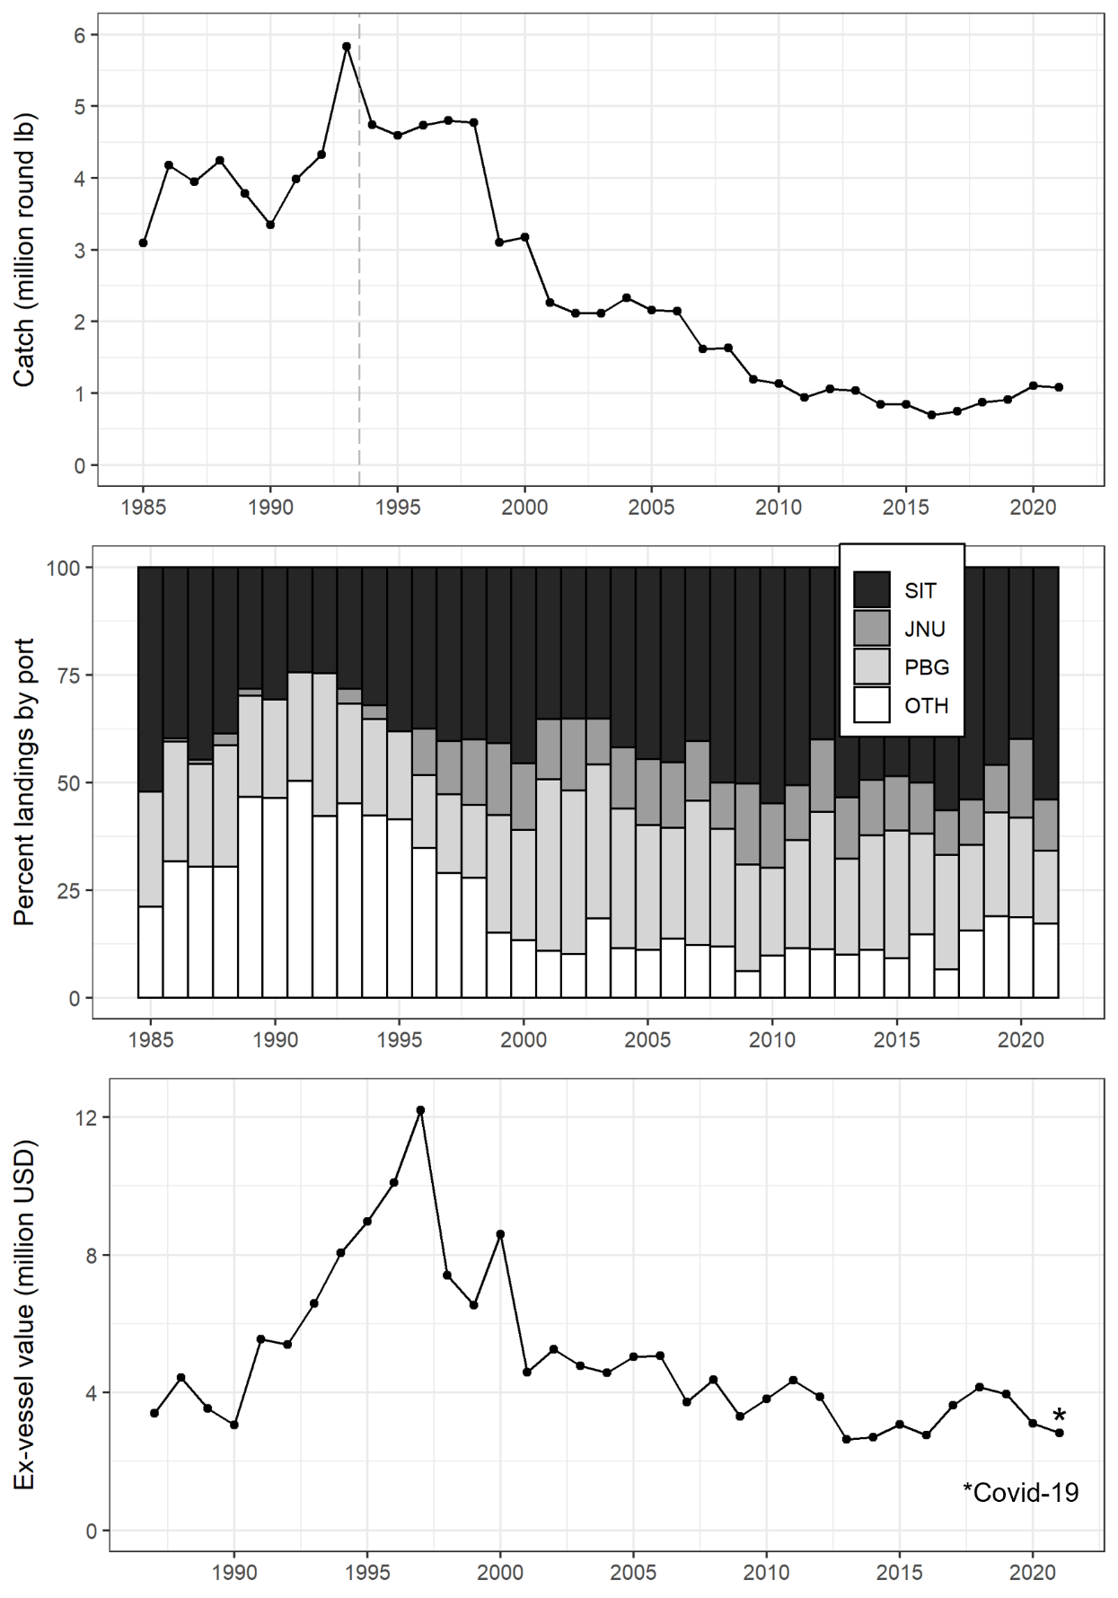

Figure 2.–Catch, landings by port, and ex-vessel value for Northern Southeast Inside (NSEI) Subdistrict commercial sablefish 1985–2021. The asterisk denotes the COVID-19 pandemic and potential effects on ex-vessel value in 2021.

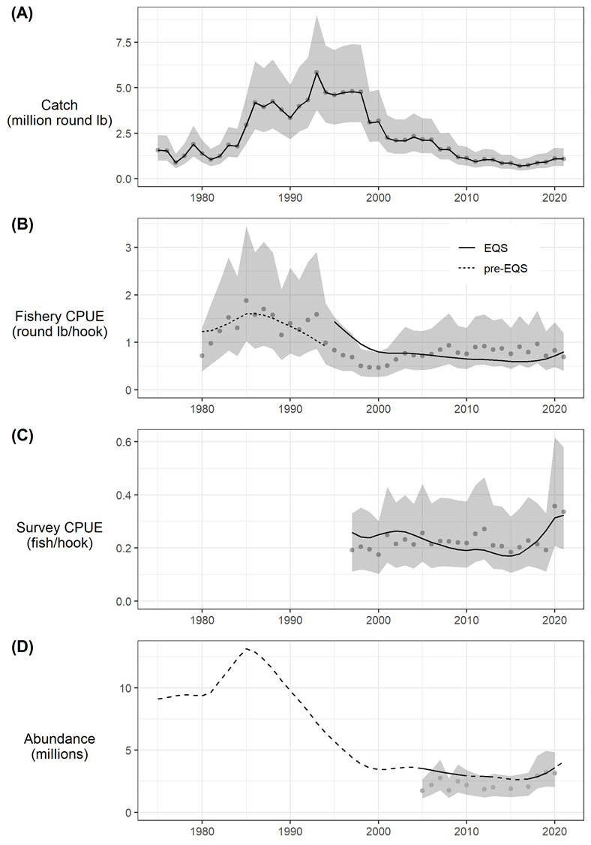

Figure 3.–Fits to indices of catch and abundance with the assumed error distribution shown as shaded grey polygons. Input data are shown as grey points and model fits are shown in black. Indices include (A) harvest (million round pounds); (B) fishery catch per unit effort in round pounds with separate selectivity and catchability time periods before and after the implementation of the Equal Quota Share (EQS) program in 1994; (C) survey catch per unit effort in number of fish per hook; and (D) mark-recapture abundance estimates in millions. Solid and dashed-lines in panel D reflect years for which data were and were not available, respectively.

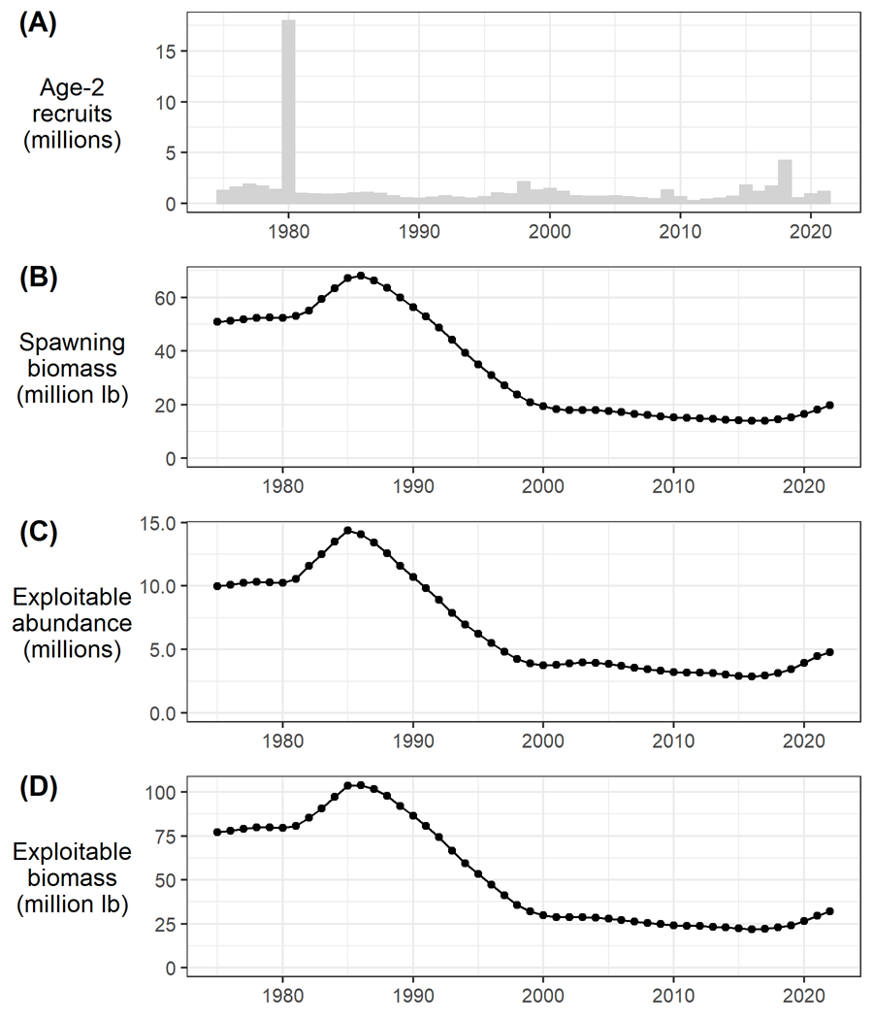

Figure 4.–Model predictions of (A) age-2 recruitment (millions); (B) female spawning stock biomass (million pounds); (C) exploitable abundance (millions); and (D) exploitable biomass (million pounds).

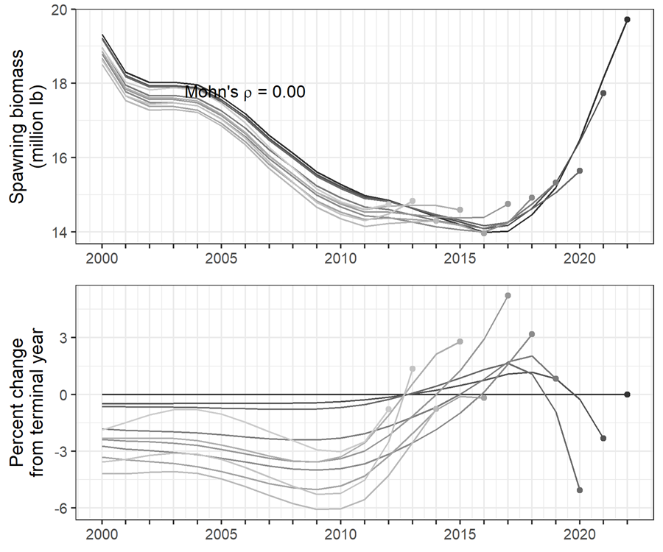

Figure 5.–Mohn’s r and retrospective peels of sablefish spawning biomass.

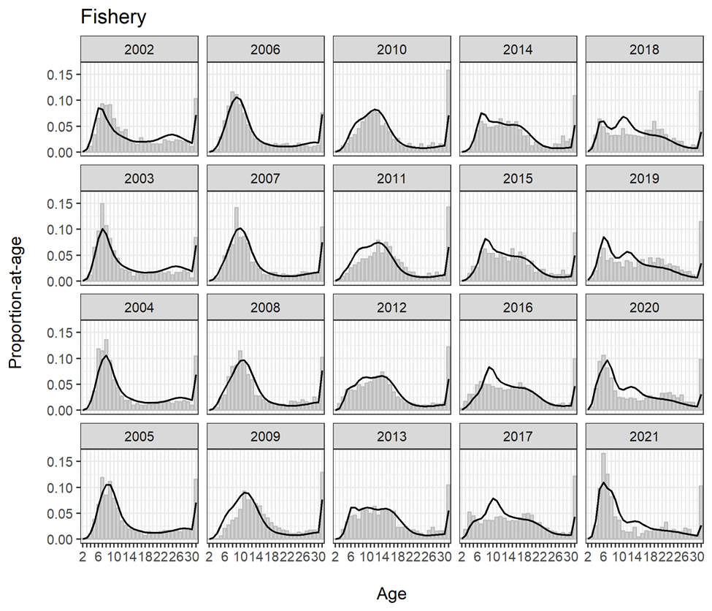

Figure 6.–Fits to fishery age compositions, 2002–2021. Observed (gray bars) and predicted proportions-at-age (black lines) shown.

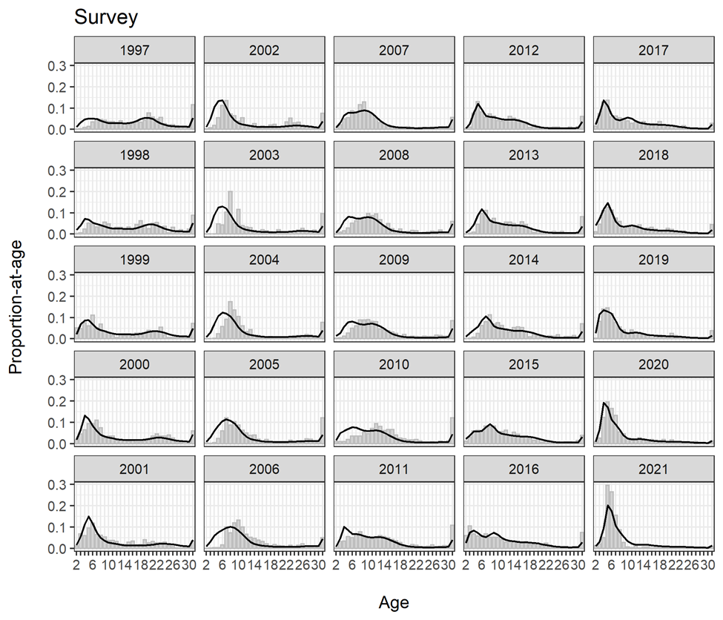

Figure 7.–Fits to survey age compositions, 1997–2021. Observed (gray bars) and predicted proportions-at-age (black lines) shown.

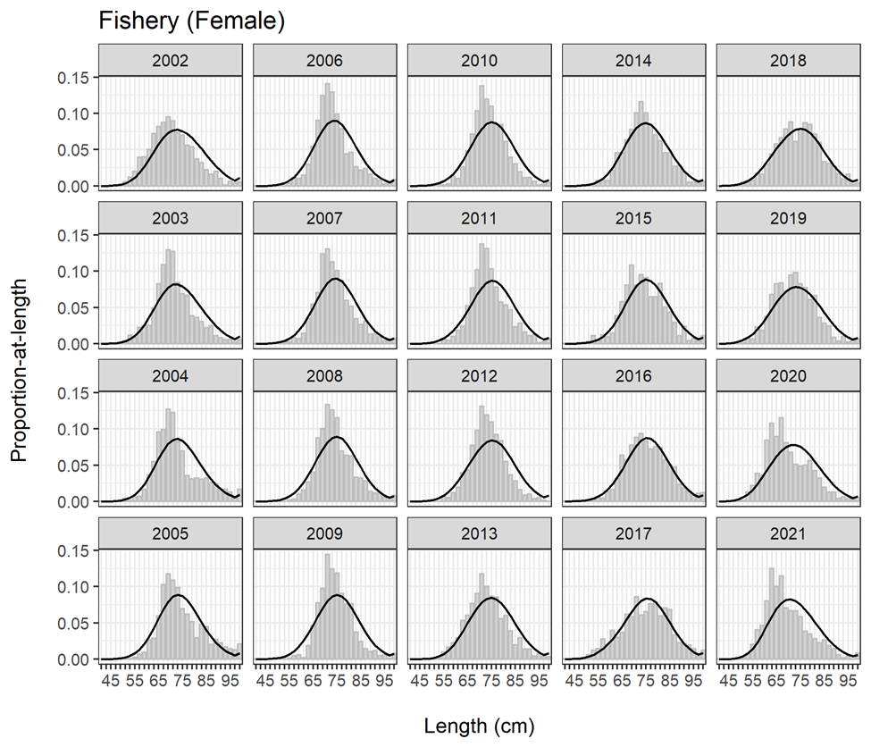

Figure 8.–Fits to female fishery length compositions, 2002–2021. Observed (gray bars) and predicted proportions-at-age (black lines) shown.

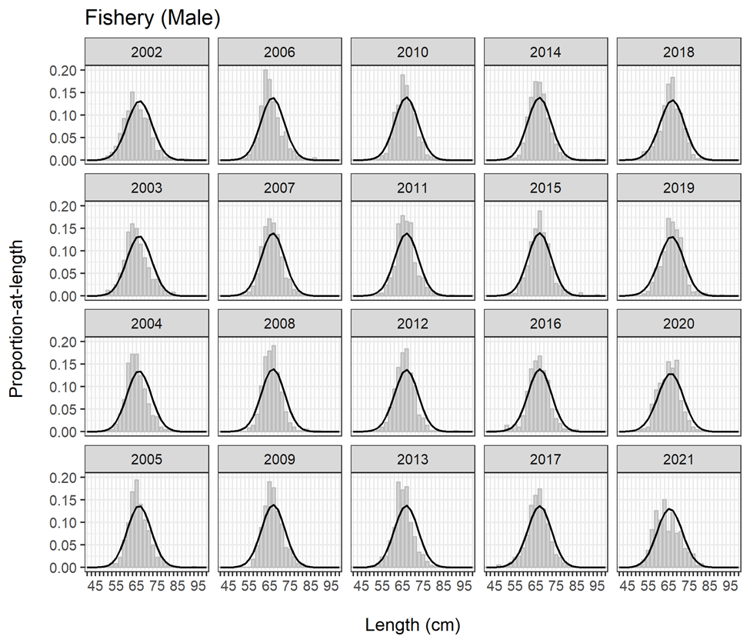

Figure 9.–Fits to male fishery length compositions, 2002–2021. Observed (gray bars) and predicted proportions-at-age (black lines) shown.

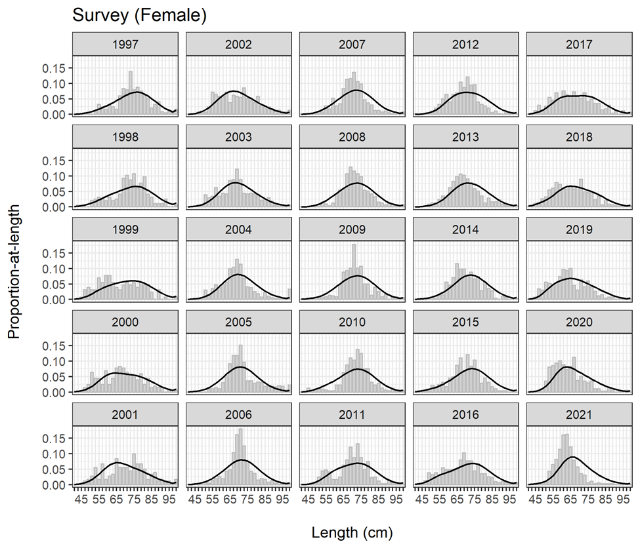

Figure 10.–Fits to female survey length compositions, 1997–2021. Observed (gray bars) and predicted proportions-at-age (black lines) shown.

Figure 11.–Fits to male survey length compositions, 1997–2021. Observed (gray bars) and predicted proportions-at-age (black lines) shown.